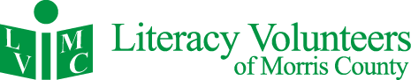

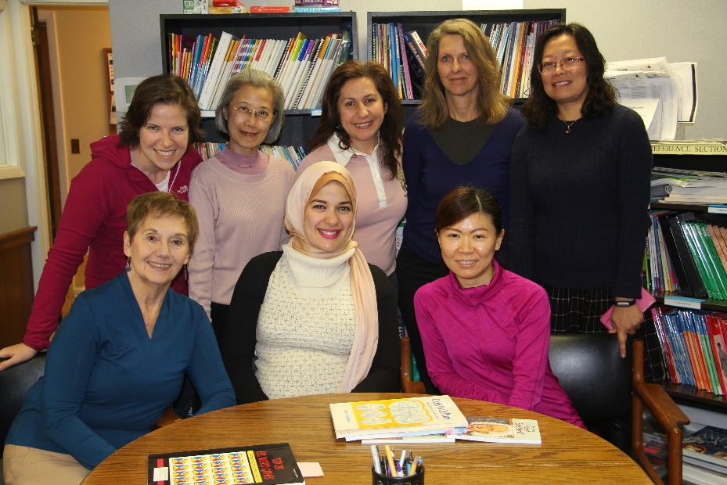10 Pine Street, Morristown, NJ 07960 [www.lvmorris.org](http://www.lvmorris.org)

2016 ANNUAL REPORT

**ABOUT US**

Literacy Volunteers of Morris County (LVMC) offers free in-person literacy instruction to help adults function independently in society. The organization has provided foundational support for one-on-one and group lessons for more than 30 years. LVMC is one of the largest literacy programs in New Jersey and maintains certification by ProLiteracy, a national adult literacy standards group.

“In the last five years, our students have achieved over 10,000 personal goals.”

With the dedication of volunteers and part-time staff, LVMC is able to keep expenses to less than $1 dollar per student, per day. In addition to individual and small group tutoring, we provide instruction in pronunciation, US history, preparation for the US citizenship test, American customs and manners, math, basic essay writing, resume guidance, and GED preparation.

**Our Students**

We serve any person who needs help with foundational English communication or math skills. This includes people who were born in the United States and those who have come here speaking other languages. Our ESL students come from over 70 different countries.

**Our Tutors**

Volunteers receive comprehensive training on basic teaching skills and cultural awareness. Tutors receive logistical support from our staff and access to a library of materials designed for the adult learner.

**Each Year**

Together, tutors, students, and staff help accomplish thousands of individual goals. In the last five years, students achieved over 10,000 goals: more than 250 were able to find a job; more than 150 became US citizens; hundreds were able to start college, vote, use a computer, handle their medical care, and become more independent, engaged, and self-sufficient members of our community.

Please continue reading for more details on our work this past year. Thank you for helping us give the gift of literacy!

***Debbie Leon***

Executive Director

**We open more than books, we open doors**

**2016 PROGRAM OVERVIEW**

**In 2016,**

More than 1,000 students attended our programs.

90% studied English as a second language

104 Basic Literacy learners worked to improve reading, writing and basic math skills

Of the students with regular attendance, 72% achieved their literacy goal

Overall, 44% of our students achieved their literacy goals

36 of our unemployed students were able to find jobs

86 improved their ability to perform their job

13 who received a promotion as their skills improved

43 individuals improved their parenting skills

28 students became citizens

24 students were better able to manage their health care needs

334 reported being better able their basic survival needs independently

**LVMC Changes Lives**

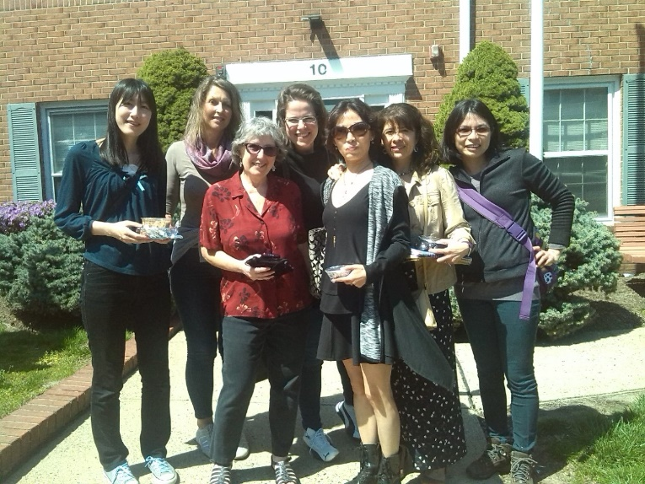Our students’ inability to communicate impacts negatively upon their ability to work, raise their families, and fully function as members of society. We aim to help each student reach his or her own individual goal, whether it is to find a job, become a US citizen, or help their child with their homework. With personalized instruction, our students can progress at their own pace and begin to gain confidence in their communication skills.

**REFLECTIONS FROM TUTORS AND STUDENTS**

“I have learned a lot about America through LVMC; like their culture, the complicated voting system, the current issues, etc. It really helps me understand about America and their customs. I am thankful to all the staff at LVMC, because they always say, “Hello, how are you?” with very smiling faces, so I feel comfortable and welcome to come to LVMC. I remember the first day I visited the building. I hesitated to go in, but your warm and nice smiles blew my worries away. Most of all, I’m thankful to meet all the teachers and people there. They are so valuable to me. I’m so happy that I have a chance to be at LVMC. Thank you all.

*Kimberly from Korea*

“It made us feel welcome to America. It makes me feel there are so many wonderful people who are willing to take extra time to help others.

*Liyun from China*

“Thanks to the LVMC I have accomplished my school goals. Fifteen years ago I did not speak any English or have a high school diploma; but today, I am 5 classes away from finishing my college degree and LVMC has helped me through it all. I am also thankful to LVMC for helping me pass my classes and giving me hope for the future, because I did not quit. I really would like to thank all the team that makes this amazing program a success, but especially to my dear tutor and mentor, Mrs. Janice. Thank you.”  *Simone from Brazil*

“I get to share some of the skills that have helped me be successful, and I get to meet interesting people from my own community and around the world!” *Lynn Dolan, Tutor since 201*6

“I am thankful to LVMC because for the first time in my life I have the opportunity to study for free and I have finally become fluent in English. This is only possible due to the impressing dedication, patience and passion for all the teachers at LVMC. Besides this, it is a unique experience due to all the great professors. I have also met people from all over the world. They are all awesome and very friendly.”

*Milena from Brazil*

“They are making a big difference in our lives. We learn the language, customs and a lot of other things about the Country who adopted us. Because of you, we are feeling here like …home. Your motto is, “we open more than books, we open doors”. You are doing much more than that, you are opening your hearts and everything you are doing for us makes us to feel welcome and HOME. We can speak same language now and we can express our feelings of gratitude. Thank You. “ *Vio from Romania*

“My students enrich my life and teach me so much!”

*Pamela Estevez, Tutor since 2014*

“I am thankful to LVMC because it has enlightened me with knowledge of the world. The ability to communicate in reading and writing; and to express my thoughts.”

*Norman from Jamaica*

“I no longer fear learning the English language. It has helped me greatly at my career and all aspects of my life. I am thankful to LVMC because I got to meet my wonderful mentor Sarah!”

*Ken from China*

“It has given me the opportunity to help others and give back to my community. It’s so fulfilling.”

*Rebecca Karger, Tutor since 2015*

“I am learning a lot, not only the English language; but about the American history and culture. Our tutor, Mr. Russ, is a very dedicated person and we are very thankful to LVMC for giving us this opportunity. “ *Maria from Cuba*

**ANNUAL EVENTS**

**Turkey Trot**

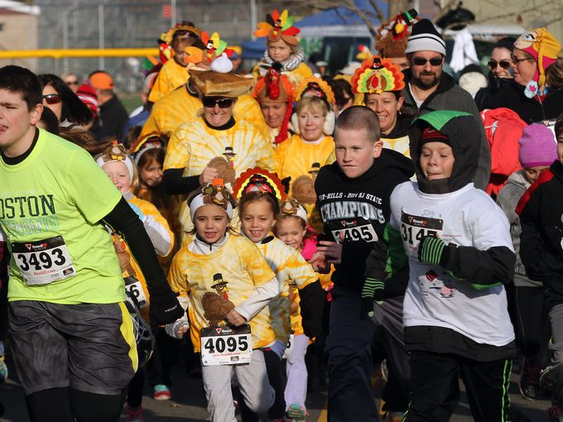Every year, LVMC partners with the Interfaith Food Pantry to host a 5K race on Thanksgiving Day. Our organizations come together to suppose those who are less fortunate, which is something that many of us think about each year at Thanksgiving. Running for these causes provides an opportunity to celebrate that is healthy, fun, and has become a tradition for many Morris County residents. The event raises more than $30,000 for each organization and also helps raise awareness of the needs in our community.

**Thanksgiving Potluck Supper**

To celebrate our community, LVMC holds a dinner each year at Thanksgiving time. More than one hundred tutors, students, staff, and volunteers came together to enjoy great food and company, and acknowledge the accomplishments of the year. We also celebrated our 2016 tutors of the Year: Alice Long, Pat Libak, and Kay Kribs, and recognized Ann and Bruce Stachenfeld of the Sweetie Pig Foundation for their generous support of our program.

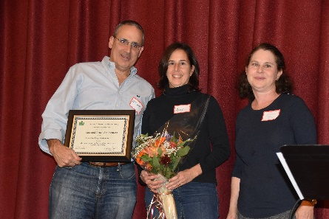

Ann and Bruce Stachenfeld from the Sweetie Pig Foundation

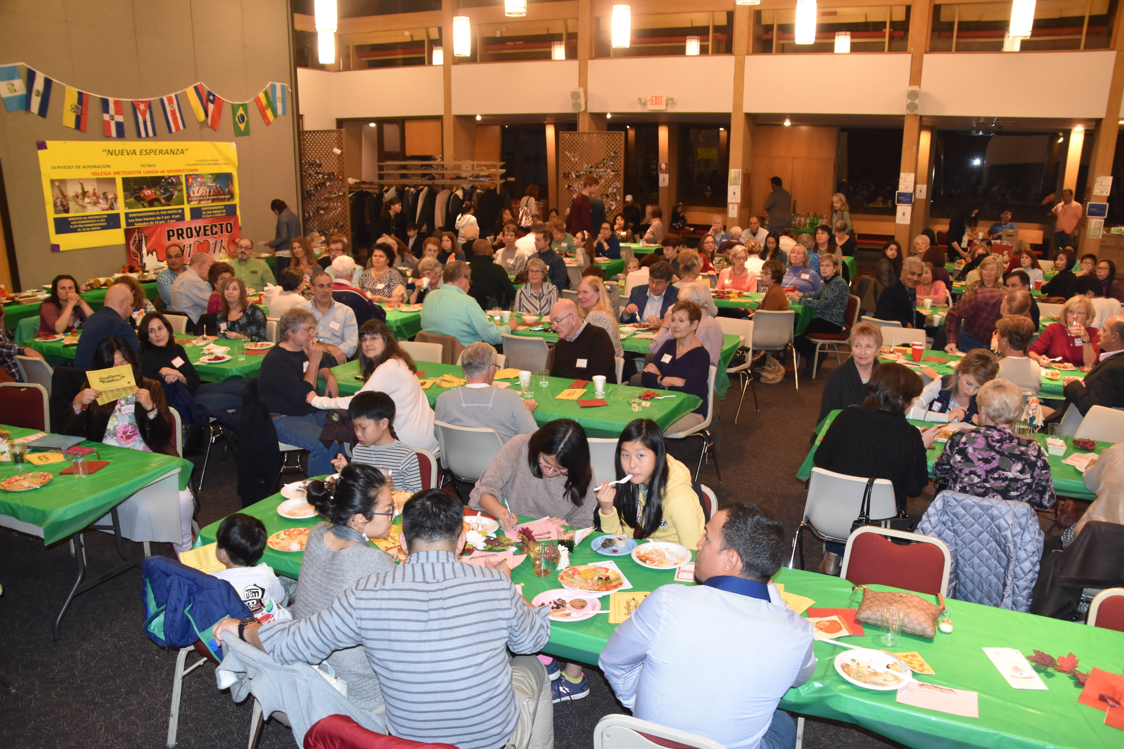

**2016 FINANCIAL STATEMENT**

**Revenues**

Foundations and Corporate Grants $ 151,420

United Way $ 9,923

Individual Contributions $ 27,471

Program Fees $ 6,361

Special Events $ 53,179

Other Income $ 170

**Total $ 248,524**

**Expenses**

Program $ 209,898

Management $ 24,903

Fundraising $ 2,225

**Total $ 237,026**

**Net Assets $ 151,007**

**CORPORATE, FOUNDATION AND COMMUNITY SPONSORS**

|  |  |
| --- | --- |
| Atlantic Sports Health* | Morris County Chamber of Commerce* |
| Bank of America | NJ Tau Chapter of Delta Kappa Gamma |
| Boye Foundation | North Jersey Development Group* |
| Chatham United Methodist Church | Novartis |
| Community Foundation of New Jersey | Pfizer Foundation |
| Chrysalis Pharma Partners* | PNC Charitable Trust |
| Deluxe Corporation | Provident Bank Foundation |
| Dixon Brothers* | Putnam Rolling Ladder |
| Don & Mel Fink’s IronFit* | Raymond James & Associates* |
| Greater Morristown YMCA* | Rogers Family Foundation |
| Fulton Bank of New Jersey | Rotary Club of Madison |
| Gloria Dei Lutheran Church | Rotary Club of Morristown |
| Paula & Jerry Gottesman Foundation | Staples |
| Hyde & Watson Foundation | Spavia of Greater Morristown* |
| Investors Bank Foundation | Sweetie Pig Foundation |
| Johnson & Johnson | T&E Industries* |
| F.M. Kirby Foundation | TJX Foundation |
| KPMG | United Way of Northern New Jersey |
| Lillian Schneck Foundation | Verizon |
| Lexus of Route 10* | Wells Fargo |
| Merck, Inc. | Wish You Well Foundation |
|  |  |
|  |  |
|  |  |
|  |  |
|  | * Denotes Turkey Trot Sponsor |

**INDIVIDUAL DONORS**

|  |
| --- |
| Alicia Adarve |
| Minoo Advani |
| Eleanor & Richard Aiken |
| Jodi Lee Alper |
| Heather Althoff |
| Joan Anderson |
| Carmen Anglada |
| Ed Antal |
| Joan Aquino |
| Aura Avila |
| Tin Tin Aye |
| Kathleen Banks |
| Linda & Jim Barratte |
| Michael Baruffi |
| Janie & Philip Bell |
| Beth Berger |
| Marlene Besdansky |
| Gloria Biolsi |
| Kenneth & Sheri Blankfein |
| Priscilla Boles |
| Mary Boniakowski |
| Jeffrey Braemer |
| Amy Brunswick |
| Longjie Bu |
| Maria Buckel |
| Donna Burkey |
| Robert & Mary Bush |
| Geneva Campbell |
| Linda Carella |
| Raymond Carriere |
| Ray & Beverly Casarico |
| Usha Chandra |
| Ai Ling Chao |
| Helen Chen |
| Lina Chen |
| Shirley Chen |
| Doug & Joyce Cheppo |
| Sandy Cherniack |
| Esther Chiarolanzio |
| Faith Chinskey |
| Lily Chu |
| Nancy Chu |
| Allison Clark |
| Dan Cohen |
| Marla Cohen |
| Richard Cohen |
| John Cohn |
| Linda Connors |
| Judy Conroy |
| Fred Corona |
| Barbara Couillard |
| Rob & Tracy Crigler |
| Mike Daly |
| Maria DaSilva |
| Lisa Davis |
| Israel DeJesus Campos |
| Marie-Claire Deballon |
| Andrew Del Colle |
| Jim & Diane Dellureficio |
| Carolyn DeLorenzo |
| Inge DiGiacomo |
| Lynn Dolan |
| Yueli Du |
| Greg & Eileen Duch |
| Jill Dupuy |
| Nancy Ebeling |
| Miriam Eddleman |
| William Ennis |
| Pamela Estevez Cizeski |
| Pamela Etzold |
| Cara Evans |
| Robert Falcone |
| Carol & Jim Falk |
| Charlotte Farlow |
| Dana Faulkner-Punzo |
| Ana Isabel Fernandez |
| Sheila Figman Eule |
| Chanena Figueroa |
| Mel & Don Fink |
| Paula Firestone |
| Mary Fleming |
| Maria Florez |
| Rodney P. Frelinghuysen |
| David & Jennifer Friedland |
| Diane Fristachi |
| Gardner Family Fund |
| Kathleen Gardner |
| Joe Gehrum |
| Robert Geise |
| Mija Gellerman |
| Melissa Gencarelli |
| Terry Glick |
| Gomez, German |
| Gloria Gonzales |
| Steve Goscinski |
| Geordie Grant |
| Kim Grantham |
| Printipa Grongsaard |
| Laurie & Philip Gross |
| Don Guerin |
| Toni Guss |
| Wendy Halliburton |
| James & Julie Hamilton |
| James Hanrahan |
| Roger Harkavy |
| Mark & Marilyn Heckler |
| Meghan Heyert |
| Genevieve Hogan |
| Marie Hogarty |
| Sharon Holgate Sunderland |
| Nataliia Hosteiva |
| Jih-Han & Mali Hsieh |
| Monica Izurieta |
| Sandra Jacobson |
| Mariana Karpatova |
| Barbara Keelty |
| Ann Kelsey |
| Soon Kil |
| Kathleen & Robert Kirpitch |
| Laurie Klauber |
| Lyane Kleinman McAuliffe |
| Anne Kneller |
| Eleanor Kopido |
| Alice Koster |
| Marianne Kozlowski |
| Kay Kribs |
| Karin Kruse |
| Steve Kwasney |
| Polly & Ron Lacey |
| Michele Rossari Lake |
| Susan Landau |
| Maribel Largo |
| Nancy & Gregory Leck |
| Kum Ja Lee |
| Pauline Lee |
| Carol & Charles Leiwant |
| Steven Lemmo |
| Lois Lenar |
| Marcela Isabela Lenox |
| Tina Levorse |
| Alexander Leyzerov |
| Patricia Libak |
| Lida Libman |
| Rachel Lin |
| Sammy LIn |
| Helen Harris Lindeman |
| Sandy-Lin Mordini |
| Ken Lipkin |
| Alice Long |
| Francisco Lopez |
| Kathleen Lorber |
| Jeanine Madden Losito |
| Lucy Loux |
| Margaret Lozauskas |
| Patricia Luthy |
| Jim & Barbara MacHale |
| Patricia Manfre |
| Jenny Mantek |
| The Paula & William J. Marino Family Foundation |
| Rosalie & Robert Marmara |
| Jordi Marti |
| Bradley Maykow |
| Alexandra McClure |
| Valerie McCoy |
| Christopher McDonagh |
| Virginia McDonnell |
| Helen McFarlane |
| Douglas McMahon |
| Ashley Melnik |
| Suqin Meng |
| Akil Mesiwala |
| Diane Meza |
| Mary Ann Michalski |
| Diane Miller |
| Muriel Millman |
| Dolores Mirrione |
| Patricia Mitchell |
| Erlizabeth Montecinos Patino |
| Roy Morance |
| Valerie Morgan |
| Sally Muscarella |
| Howard Myers |
| Kodsia Najem |
| Susette Naylor |
| Jeanne Nicols |
| Maria Norton |
| Lorraine Novinski |
| Karen Zanko Ocker |
| Kimberly Oh |
| Dave & Heather Ondrejcak |
| Maria Fernanda Ospina |
| Barbara Owens |
| Joe and Mildred Paden |
| Gigi Pallotta |
| Madeline Pasteelnick |
| George Patterson |
| Ellen & Alan Pearl |
| Tamara Pearsall |
| Terence Peavy |
| Jeanne Perry |
| Irene Phillips |
| The Pierson Family Foundation |
| Lorena Pisco |
| Elizabeth Poore |
| Janet Proscia |
| Christine Rachalis |
| Kenneth Ratigan |
| Frank Razanno |
| Carmen Mariana Reiban |
| Jeff Remaly |
| Ronald Ribnik |
| Nicholas & Ann Ricculli |
| Marjorie Rice |
| Nick Rimassa |
| David Rivchin |
| Carole Rogers |
| Michelle Rosseri |
| Joanne Roukens |
| Amy Rubinetti |
| Anna Rusinskaia |
| Dominichia Rusinskaia |
| Janice Rutherford |
| Maria Saldivar |
| Lorna Samaneigo |
| Madelon Sarti |
| Sabine Schirmer |
| Ann Schneider |
| Alex Scott |
| Tanya Seaward |
| Constance Seligman |
| Nancy Shamdosky |
| Constance Shanley |
| Faina Shilkrot |
| Susan Siegrist |
| Madeline Sinoway |
| Barbara Snyder |
| Gordon Snyder |
| Claudia Sorto |
| Howard Stein |
| Charles Steinberg |
| Marie Stiven |
| Barbara & John Stromberg |
| Tim Sugrue |
| John Svolos |
| Marta Bibiana Swieszkowski |
| Joanne Tabeek |
| Susanne Thevenet |
| David Ticker |
| Susan Ticker |
| Bevin Tierney |
| Pat & Roni Tobia |
| Nilgun & Nadir Uysal |
| Jane Van Wiemokly |
| Juan Jose Vargas |
| Marianna & Remo Vigano |
| Aida Visakay |
| Linda Vivilecchia |
| Mary & Jim Walker |
| Eileen Walsh |
| Niratana Wanchan |
| Scarlett Wang |
| George & Josephine Washburn |
| Bryna & Branch Watkins |
| Sally Jo Weber |
| Sherry Weiinder |
| Sara & Robert Weissman |
| Hu Wenting |
| Kent Werry |
| Joan Willoughby |
| Charlotte Wilson |
| Royce & Doug Wintz |
| Meg & Jim Wiviott |
| Beth Wolff |
| Kathy Wu |
| Lang & Jenny Wu |
| Yuling Wu & Xianlin Zhang |
| Wei Yang |
| Kathy Youzwak |
| Gongxia Yuan & Shufang Wang |
| Ziaoluo Yuan |
| Yu Chen Yun |
| Brigid & Steve Zajac |
| Karen Zaske |
| Magdalena Zavala |
| Jenny Zhang |
| Carol Zimmermann Joyce |
| Martina Zuwolinsky |

**THANK YOU TO OUR GENEROUS DONORS!**

Every attempt has been made to recognize the generous contributions of our donors.   
We apologize for any errors. If you feel that your name should appear on this list, or if it appears  
 incorrectly, please let us know!

**YOUR DONATION**

LVMC receives no government funding, and relies completely on support from individual and corporate donors. Contributions help us provide the infrastructure to make each lesson possible. Overhead costs are kept low to ensure that funding can support our tutors and students.

**100%** of our funding comes from community supportand **.90 cents** of every dollar directly supports our students and tutors

**How do we use the money you donate?**

$40 provides a one year newsletter subscription for a student

$50 helps a student prepare for the General Equivalency Diploma (GED)

$150 sponsors an English as a Second Language student for one year

$250 sponsors a Basic Literacy student for one year

$200 pays for test preparation materials for US Citizenship

$1,000 trains 25 new volunteer tutors

$2,275 supports our facility cost for one month

$2,500 updates our lending library for an entire year

**OUR MISSION**

**Literacy Volunteers of Morris County** believes that the ability to read, write, comprehend and speak English is essential for personal freedom and the sustainability of a democratic society. Our mission is to provide free instruction to Morris County adults in literacy, English fluency and American culture.

|  |  |
| --- | --- |
| **Officers**  Karin Kruse, President  Nick Rimassa, Vice President  Allison Clark, Treasurer  Susan Ticker, Secretary | **Board of Directors**  Ray Casarico  German Gomez  Steve Goscinski  John Launchi  Diane Miller  Alex Scott |
| **Staff**  Debbie Leon, Executive Director  Kathy Talbert, ESL Coordinator  Bevin Tierney, Training and Adult Ed Coordinator  Ivellisse Ramos, ESL Program Assistant  Elizabeth Gavilanes, ESL Program Assistant  Rosalie Marmara, ESL Program Assistant | |

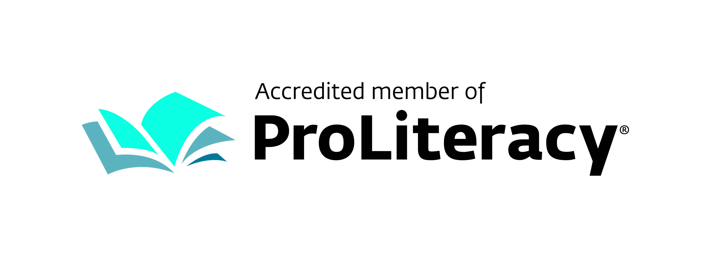

Literacy Volunteers of Morris County 10 Pine Street Morristown, NJ 07960 [www.lvmorris.org](http://www.lvmorris.org)