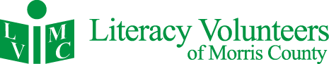

10 Pine Street, Morristown, NJ 07960 [www.lvmorris.org](http://www.lvmorris.org)

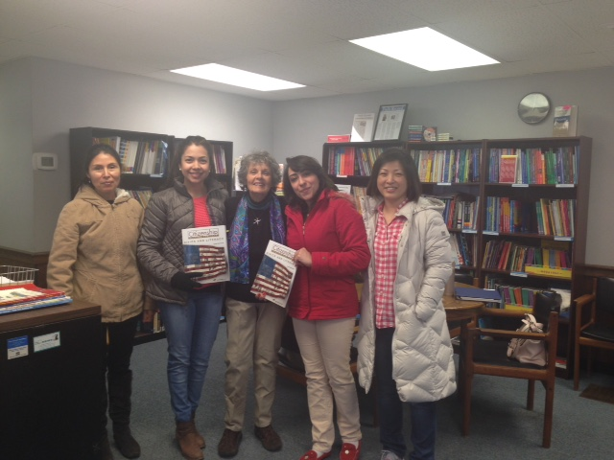2015 ANNUAL REPORT

**ABOUT US**

Literacy Volunteers of Morris County (LVMC) offers free in-person literacy instruction to help adults function independently in society. The organization has provided foundational support for one-on-one and group lessons for more than 30 years. LVMC is one of the largest literacy programs in New Jersey and maintains certification by ProLiteracy, a national adult literacy standards group.

“In the last five years, our students have achieved over 10,000 personal goals.”

With the dedication of volunteers and part-time staff, LVMC is able to keep expenses to less than $1 dollar per student, per day. In addition to individual and small group tutoring, we provide instruction in pronunciation, US history, preparation for the US citizenship test, American customs and manners, math, basic essay writing, resume guidance, and GED preparation.

**Our Students**

We serve any person who needs help with foundational English communication or math skills. This includes people who were born in the United States and those who have come here speaking other languages. Our ESL students come from over 70 different countries.

**Our Tutors**

Volunteers receive comprehensive training on basic teaching skills and cultural awareness. Tutors receive logistical support from our staff and access to a library of materials designed for the adult learner.

**Each Year**

Together, tutors, students, and staff help accomplish thousands of individual goals. In the last five years, students achieved over 10,000 goals: more than 250 were able to find a job; more than 150 became US citizens; hundreds were able to start college, vote, use a computer, handle their medical care, and become more independent, engaged, and self-sufficient members of our community.

Please continue reading for more details on our work this past year. Thank you for helping us give the gift of literacy!

*Debbie Leon*

Executive Director

**We don’t just open books, we open doors.**

**2015 PROGRAM OVERVIEW**

**In 2015,**

More than 1,000 students attended our programs.

90% studied English as a second language

99 Basic Literacy learners worked to improve reading, writing and basic math skills

Of the students with regular attendance, 80% achieved their literacy goal

Overall, 50% of our students achieved their literacy goals

29 of our unemployed students were able to find jobs

92 improved their ability to perform their job

14 who received a promotion as their skills improved

38 individuals improved their parenting skills

13 students became citizens

12 learned to handle their personal finances

335 reported being better able their basic survival needs independently

**LVMC Changes Lives**

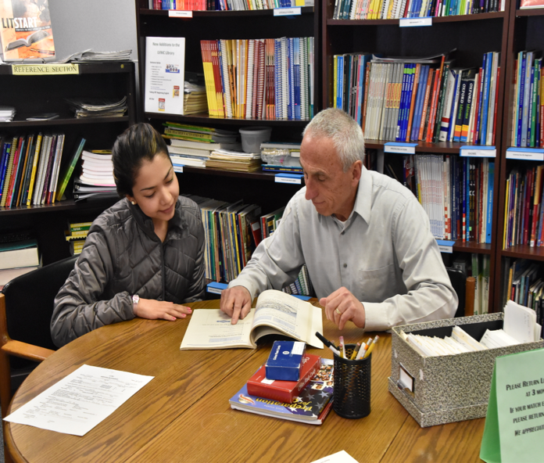Our students’ inability to communicate impacts negatively upon their ability to work, raise their families, and fully function as members of society. We aim to help each student reach his or her own individual goal, whether it is to find a job, become a US citizen, or help their child with their homework. With personalized instruction, our students can progress at their own pace and begin to gain confidence in their communication skills.

**REFLECTIONS FROM TUTORS AND STUDENTS**

|  |  |
| --- | --- |
| “I find tutoring very rewarding and I really look forward to preparing each lesson and of course teaching.” Amy Rubinetti, Tutor  “Thanks to all of you at Literacy Volunteers of Morris County for the opportunity to give something back to my community.” Robert Garry, Tutor  “You offer a great opportunity for adults to learn the English language in a very supportive environment.” Sister Margaret Foster, Tutor  “Being a tutor is very rewarding to me.” Sakti Sohan, Tutor  “I have met so many eager, hardworking students who have become such good friends” Marilyn Carnicelli, Tutor  “I am very, very thankful for this experience. Thank you all for doing such excellent, important work!” Mary Sohan, Tutor  “I’m crazy about my students—they are so smart and joyful.” Sarah Ketchum, Tutor  “I like helping students be a part of our society by learning English and American culture.” Margarita De Young, Tutor  “I can help people to reach their dream of becoming an American citizen.” Raymond Carriere, Tutor  “LVMC is like family. If you need to talk, listen, or need support, someone is always there to help.” Linda Connors, Tutor  “This program allows me to do what I love to do, and supplies me with everything I need from the students to the materials for teaching and room to teach the class.” Nancy Cunningham, Tutor  “It has given me a chance to appreciate how much it means to work so hard for something and achieve it.” Susanne Thevenet, Tutor  “Each student is grateful and eager to learn. I can never thank you enough for all the help you provide.” Maryanne Walldorf, Tutor | “Thank you for giving me the opportunity to learn more about American history which helped me pass my citizenship test.” *Monica, student from Peru*  “My tutor really improved my English skills and gave me the courage to pursue a higher education.” *Sandra, student from Mexico*  “Literacy Volunteers gave me the confidence in my English to go to job interviews.” *Maxim, student from Russia*  “I improve my English and I continue learning every day.” *Maria, student from Colombia*  “Language is the greatest help for integration. I have improved my life.” *Ligita, student from Latvia*  “The volunteers graciously spend their time to help us learn a second language.” *Byung-Seung, student from Korea*  “I feel blessed because I have a tutor and one day I can have a better job.” *Maria, student from Mexico*  “Because of LVMC my English is more fluent.” *Sonia, student from Colombia*  “This program helped me learn English and helped me pass my GED. Now I’m in college.” *Simone, student from Brazil*  “I want to thank the tutor for her efforts and interesting topics every week.” *Anna, student from Russia*  “I’ve met so many wonderful people here. The tutors here are nice and friendly.” *Ying, student from China*  “They have helped all of our family and are continuing to help. We are thankful to you all.” *Nadir, student from Turkey*  “I’m not afraid to make phone calls and fill papers in the hospital or applications.” *Maria, student from Mexico*  “I took the US Citizenship test and passed! I’m so happy to be an official citizen of the United States of America.” *Wanna, student from Thailand*  “I appreciate LVMC’s support, effort and kindness. Thank you!” *Wonsun, student from Korea*  “I feel more comfortable expressing myself around other people.” *Ingrid, student from Colombia* |

**ANNUAL EVENTS**

**Turkey Trot**

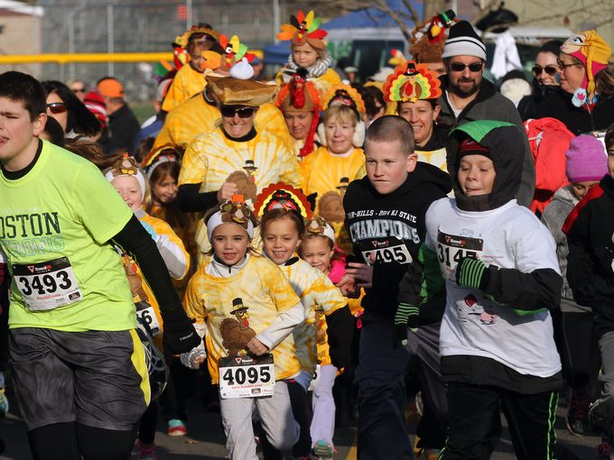Every year, LVMC partners with the Interfaith Food Pantry to host a 5K race on Thanksgiving Day. Our organizations come together because we support those who are less fortunate, which is something that many of us think about each year at Thanksgiving. Running for these causes provides an opportunity to celebrate gratitude that is healthy, fun, and has become a tradition for many Morris County residents. The event raises more than $30,000 for each organization and also helps raise awareness of the need for new volunteer tutors.

**Thanksgiving Potluck Supper**

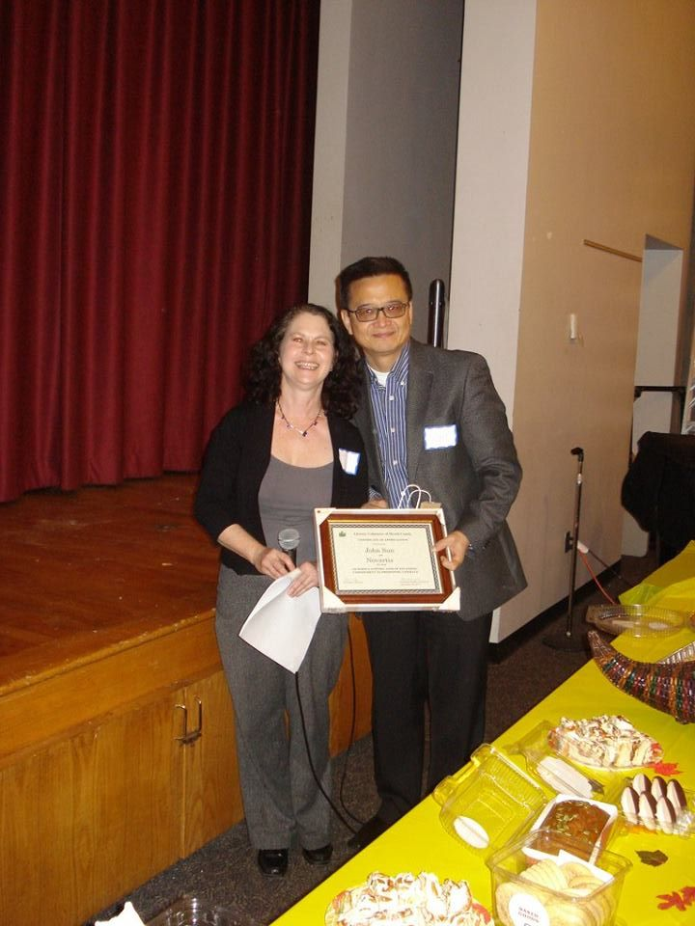To celebrate our community, LVMC holds a dinner each year at Thanksgiving time. More than one hundred tutors, students, staff, and volunteers come together and acknowledge the accomplishments of the year. The event includes a silent auction and award ceremony, celebrating our tutors of the year: Judy Bjorklund, Marilyn Carnicelli, Cliff Greenwood, Anne Kneller, Carolyn Milan, Roy Morance, Ann and Warren Rhines, and Marianne Waldorf. We also recognized Novartis for their support of our program.

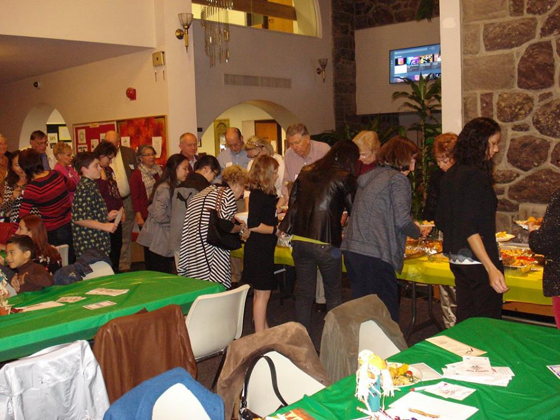John Sun, Global Project Manager, Novartis Pharmaceuticals Corporation and Debbie Leon.

**2015 FINANCIAL STATEMENT**

**Revenues**

Foundations and Corporate Grants $ 98,141

United Way $ 13,996

Individual Contributions $ 24,056

Program Fees $ 6,331

Special Events $ 63,904

Other Income $ 34

**Total $ 206,462**

**Expenses**

Program $ 206,966

Management $ 24,550

Fundraising $ 4,421

**Total $ 235,937**

**Net Assets $ 139,509**

**CORPORATE, FOUNDATION AND COMMUNITY SPONSORS**

|  |  |
| --- | --- |
| ADF Electrical Contractors | Merck, Inc. |
| American Animal Hospital | Mountain Lakes Public Library |
| AT&T | New York Life Foundation |
| Bank of America Corporation | NJ Tau Chapter Delta Kappa Gamma |
| Benjamin Moore | North Jersey Construction |
| Boye Foundation | North Jersey Development Group |
| Chatham United Methodist Church | Novartis |
| Community Foundation of New Jersey | Pfizer Foundation |
| Crum & Forster | Pierson Family Foundation |
| Deluxe Corporation | Provident Bank Foundation |
| Eclipse Marketing Services | Prudential |
| Eye Care 20/20 | Rogers Family Foundation |
| F.M. Kirby Foundation | Rotary Club of Madison |
| First Presbyterian Church of Succasunna | Staples, Inc. |
| Gloria Dei Lutheran Church | Sweetie Pig Foundation |
| Grace Charity Foundation | T&E Industries |
| Graphics Depot | TJX Foundation |
| Honeywell | United Way of Northern New Jersey |
| HSBC | VLV Associates |
| Jockey Hollow Foundation | Walmart |
| JP Morgan Chase | Wells Fargo |
| Kinnelon Board of Education | Wish You Well Foundation |
| Marlow Park | WithumSmith & Brown |
| McElroy, Deutsch, Mulvaney & Carpenter | Woodland Village Townhouses |

**INDIVIDUAL DONORS**

|  |  |  |  |  |
| --- | --- | --- | --- | --- |
| Shoier Abdelfattah | John Cohn | Jennifer & David Friedland | Barbara Keelty | Dolores Mirrione |
| Jenny Acaro | Carlene Colston | Rebecca Gallanter | Ann Kelsey | Hector Mislavsky |
| David Ackerman | David Conforth | Gardner Family Fund | Doree Kesselbrenner | Maryan Mohammadi |
| Irfan Ahmed | Natasha Cordero | Kathleen Gardner | Joan Kiefer | Elizabeth Montecinos Patino |
| Richard and Eleanor Aiken | Fred Corona | Puja Garg | Kathleen & Robert Kirpitch | Roy Morance |
| Nicole Alexander | Rebecca Cossin | Robin Gehrmann | Michael Klein | Valerie and Edward Morgan |
| Heather Althoff | Barbara Couillard | Joe Gehrum | Lyane Kleinman | Carol Morman |
| Joan Anderson | Rob and Tracey Crigler | Mija Gellerman | Anne Kneller | Coleen Mugnier |
| Diane Anderson | Maureen Cullen | Andrew George | Eleanor Kopido | Lynn Munn |
| Alba Angel | Michael Curi | Alesia Goginski | Alice Koster | Howard Myers |
| Carmen Anglada | Mike Daly | Harriet Goldsmith | Lyubov Kovalena | Machiko Nagata-Taylor |
| Ed and Ellen Antal | Ruby Datta | Louise Goldsmith | Nancy Krumholtz | Kodia Najem |
| Bonita Areman | Lisa Davis | Howard Goldstein | Barbara Krupinski | Jeanne Nichols |
| Sandra Aristizabal | Monica De La Torre | German Gomez | Polly and Ron Lacey | Leslie Noel |
| Tin Tin Aye | Teri DeGrande | Carlos Emilio Gomez | Eric Lademar | Maria Norton |
| Kathleen Banks | Jim and Diane Dellureficio | Steve Goscinski | Van Le | Karen Ocker |
| Mark Barron | Carolyn DeLorenzo | Gloria Gould | Mary Betsabe Leal Molina | Eileen Ogoff |
| Ara Barsamian | Kim DeMaria | Regina Gould | Nancy Leck | Jim O'Mahony |
| Laura Baskes Litwin | Abe and Rita Denowitz | Laura Grant | David Lederman | Dave and Heather Ondrejcak |
| Minal Baxi | Sarah Diamond | Kim Grantham | Lourdes Blanco & Andres Lederman | Craig Osten |
| Dean Beals | Inge DiGiacomo | Frank Grivalsky | Stephen Lee | Barbara Owens |
| Tim Beasant | Linda Ditullio | Phil and Laurie Gross | Hweyoung Lee | Joe and Mildred Paden |
| Kathleen Beebe | Lino Donati | Jay Grossman | David Leit | Manoh Panjwani |
| Susan Beekman | Cathy Dorusak | Don Guerin | Carol Leiwant | Matt Parayil |
| Janie and Philip Bell | Lawrence Driscoll | Jeannie Haber | Debbie Leon | Madeline Pasteelnick |
| Wayne Berberian | Doug Drosin | Maria Luisa Haller | Steven Levine | Victor Pastore |
| Beth Berger | Else Dub | James Hanrahan | Patricia Libak | Smit Patel |
| Nick Bergman | Greg and Eileen Duch | Roger Harkavy | Henry Lin | Tamara Pearsall |
| Susan Berkley | Jill Dupuy | Helen Harris Lindeman | Rachel and David Lin | Karen Percoco |
| Doris Bermudez | Rita Duran Vasquez | Melanie Harrow | Camila Linardi | Dana Perriello |
| Marlene Besdansky | Nancy Cutter Ebeling | Michael and Christine Haus | Ken Lipkin | Josh Peterson |
| Shefali Bhatt | Miriam Eddleman | Cheryl Hernandez | Judith Livant | Xuan Pham and Henry Dang |
| Dave Billard | Bill Ennis | Maria Hernandez | Alice Long | Piacente |
| Gloria Biolsi | Pamela Estevez | Zulma Hernandez | Sergio Lopez | Judith Pierson |
| Carmen Blanco | Neil Esposito | Gloria Herrera | Lucy Loux | Enid Pindus |
| Kenneth Blankfein | Pam Etzold | Joan Hipp | Margaret Lozauskas | Dana Pogorzelski |
| Paul Bornstein | Robert Falcone | Genevieve Hogan | Cynthia Xin Lu | Anita and Miguel Porto |
| Maria Buckel | Brian Falconer | Marie Hogarty | Patricia Luthy | Chris Prant |
| John Budzinski | Carol Falk | Sharon Holgate | Jim and Barbara MacHale | Janet Proscia |
| Peggy and Andy Bulfer | Barbara Fancher | Harison and Jociane Hong | Henry Magno | Christine Rachalis |
| Thomas A. Buonocore, PC | Charlotte Farlow | Patricia Howard | Patricia Manfre | Beth Ratner |
| Donna Burkey | Beth Feldman | Michelle Hsieh | Alice Manning | Elizabeth Rauch |
| Robert Bush | Swati Feldman | George Hunt | David Mantle | Mitchell Reiter |
| Gloria Buxbaum | Takako Matsura Fernandez | Harreit Hyams | Paula Marino | Doug and Ellen Rennie |
| Richard Carchia | Gerry Fifer | David Hyman | Rosalie and Robert Marmara | Lisa Resciniti |
| Heather Carr | Chanena Figueroa | Lisa Iervolino | Leandro Martins | Nicholas and Anne Ricculli |
| Raymond Carriere | David File | Gabriela Ilkei | Eric Maurer | Marjorie Rice |
| Michey Carroll | Philip Fina | Monica Izurieta | Valerie McCoy | Sharon and Mark Richman |
| Ray Casarico | Mel and Don Fink | Sandra Jacobson | Shelia McCullough | Holly and Patrick Riley |
| Lina Chen | Paula Firestone | JoAnn and Herbert Jamison | Christopher McDonagh | Richard Ripley |
| Sandy Cherniack | Breena Fishback | Jay Kulkarni | Douglas McMahon | David Rivchin |
| Esther Chiarolanzio | Frank and Sarah Flaherty | Elizabeth Jennison | Suqin Meng | Evelyn Roces |
| Joseph Chikvashvili | Mary Fleming | Jim Johnson | Jeanne and Greg Metzler | Michael Rosenfelder |
| Faith Chinskey | Regina Fleszar | Gudrun Johnson-Stein | Mary Ann Michalski | Alain Rothstein |
| Jeong You Choi Lee | Herger Flores | Michael Kahn | Steven Rubenstein Family Foundation | Joanne Roukens |
| Debra Chudnow | Bob Fortino | Alan Kalata | Alexander Miller | John Rudder |
| Maria Luz Cleves | Sister Margaret Foster | Peter Kalmus | Diane Miller | Claudia Sabine |
| Anthony Cohen | Rep. Rodney P. Frelinghuysen | Joanne Kares | Linda Miller | Judith Sacks Bliss Philanthrhopic Fund |
| Dan Cohen | Erik Freund | Susan Katz | Muriel Millman | Cynthia Sadler |

**INDIVIDUAL DONORS (continued)**

|  |  |  |  |  |
| --- | --- | --- | --- | --- |
| Maria Saldivar | Michael Sirkin | Robert and Elizabeth Thomas | Bryna and Branch Watkins | Susan Winkelried |
| Lorna Samaneigo | Barbara Snyder | Bernice Thompson | Timothy Weber | Royce and Doug Wintz |
| Justin Sambol | Gordon Snyder | Marcy Thompson | Nathaniel Wechsler | Meg and Jim Wiviott |
| Mary Sanchez | Cynthia Sokoloff | David Ticker | Sherry Weiner | Mary Jo Woodford |
| Pam Santos | Stanlee Stahl | Veronica Tobia | Judith Weisfuse | Jenny Wu |
| Denise Sarinelli | Robert Steidlitz & Kirsten Hotchkiss | Phuong Truong | Aylssa Weiss | Kathy Wu |
| Michael Saulich | Charles Steinberg | Richard Tunnell | Sara and Bob Weissman | Yuling Wu and Xianlin Zhang |
| Clara Savino | Norman Stone | Robert Urban | Jill Weissman | Nancy Yang |
| Shannon Schlageter | Barbara Stromberg | Nilgun and Nadir Uysal | Neil Weissman | Philip Yap-Diangco |
| Ann Schneider | Momoko Suzuki | Gabriela Vassova | Wendy Weissman | Yeliseyeva |
| Lisa Scott | John Svolos | Aida Visakay | Debby Wheeler | Elaine Yu |
| Alejandro Selvi | Fran Taitel | Linda Vivilecchia | Dennis White | Xiaoluo Yuan |
| Allison Serries | Josephy Tallerci | Brian Voynick | Roger Wilber | Brigid and Steve Zajac |
| Constance Shanley | Jinghui Tao | Maryanne Walldorf | Joan and Keith Willoughby | Jenny Zhang |
| Jianfen Shen | Evelyn Task | Niratana Wanchan | Charlotte Wilson | Robert Zufall |
| Robin Shimel-Binns | Debbie Terlizzi | Shufang Wang & GongXia Yuan | Cathy Wilson |  |
| Susan Siegrist | Susanne Thevenet | George and Bunny Washburn | Abby Winkelried |  |

**THANK YOU TO OUR GENEROUS DONORS!**

Every attempt has been made to recognize the generous contributions of our donors.   
We apologize for any errors. If you feel that your name should appear on this list, or if it appears  
 incorrectly, please let us know!

**YOUR DONATION**

LVMC receives no government funding, and relies completely on support from individual and corporate donors. Contributions help us provide the infrastructure to make each lesson possible. Overhead costs are kept low to ensure that funding can support our tutors and students.

**100%** of our funding comes from community supportand **.90 cents** of every dollar directly supports our students and tutors.

**How do we use the money you donate?**

$40 provides a one year newsletter subscription for a student

$50 helps a student prepare for the General Equivalency Diploma (GED)

$150 sponsors an English as a Second Language student for one year

$250 sponsors a Basic Literacy student for one year

$200 pays for test preparation materials for US Citizenship

$1,000 trains 25 new volunteer tutors

$2,275 supports our facility cost for one month

$2,500 updates our lending library for an entire year

**OUR MISSION**

**Literacy Volunteers of Morris County** believes that the ability to read, write, comprehend and speak English is essential for personal freedom and the sustainability of a democratic society. Our mission is to provide free instruction to Morris County adults in literacy, English fluency and American culture.

|  |  |
| --- | --- |
| **Officers**  Steve Goscinski, President  Alex Scott, Vice President  Karin Kruse, Treasurer  Allison Clark, Secretary | **Board of Directors**  Ray Casarico  German Gomez  Diane Miller  Nick Rimassa |
| **Staff**  Debbie Leon, Executive Director  Kathy Talbert, ESL Coordinator  Bevin Tierney, Training and Adult Ed Coordinator  Natalie Cioccia, ESL Program Assistant  Elizabeth Gavilanes, ESL Program Assistant  Rosalie Marmara, ESL Program Assistant | |

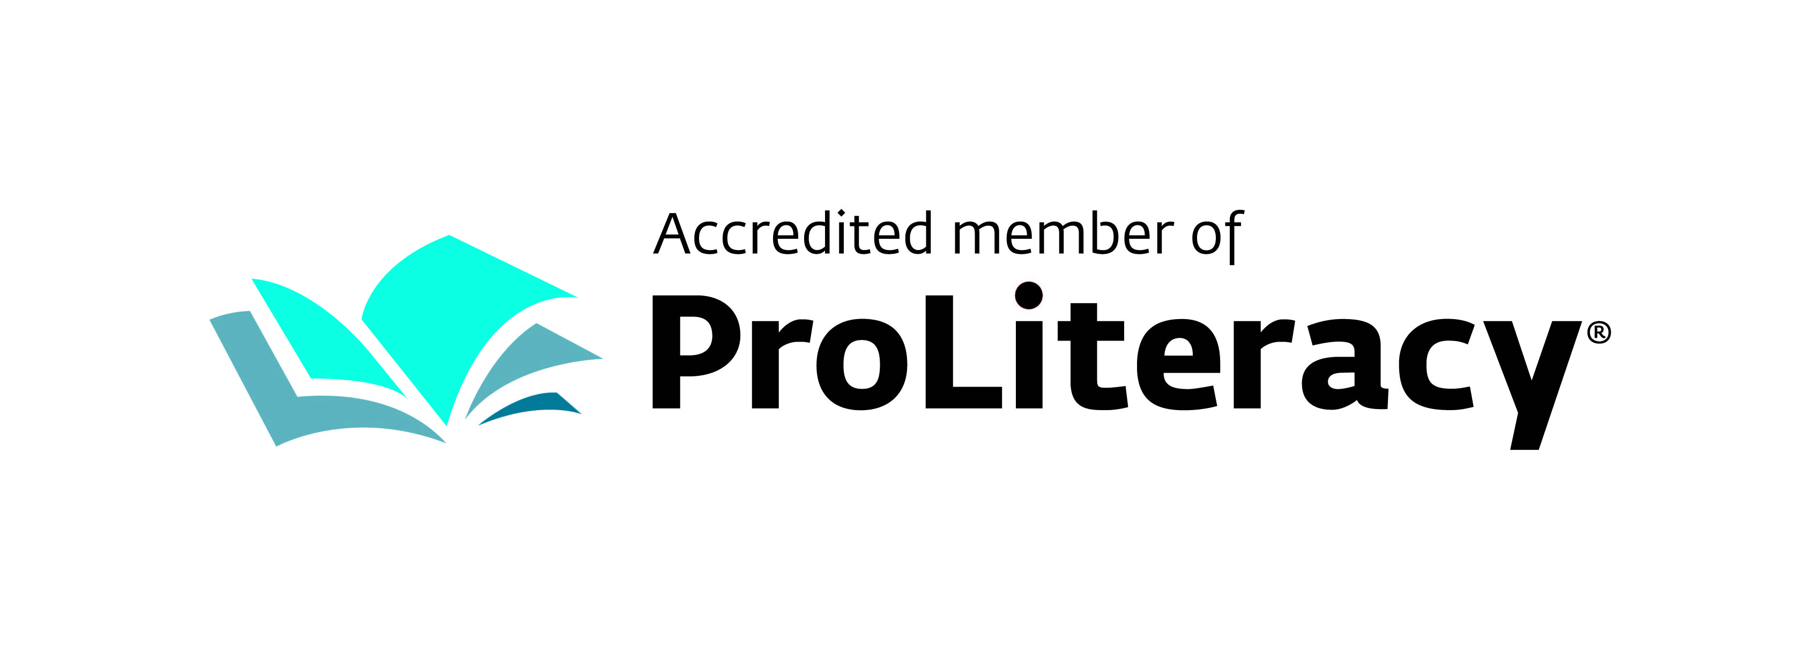

Literacy Volunteers of Morris County 10 Pine Street Morristown, NJ 07960 [www.lvmorris.org](http://www.lvmorris.org)