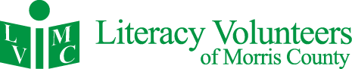
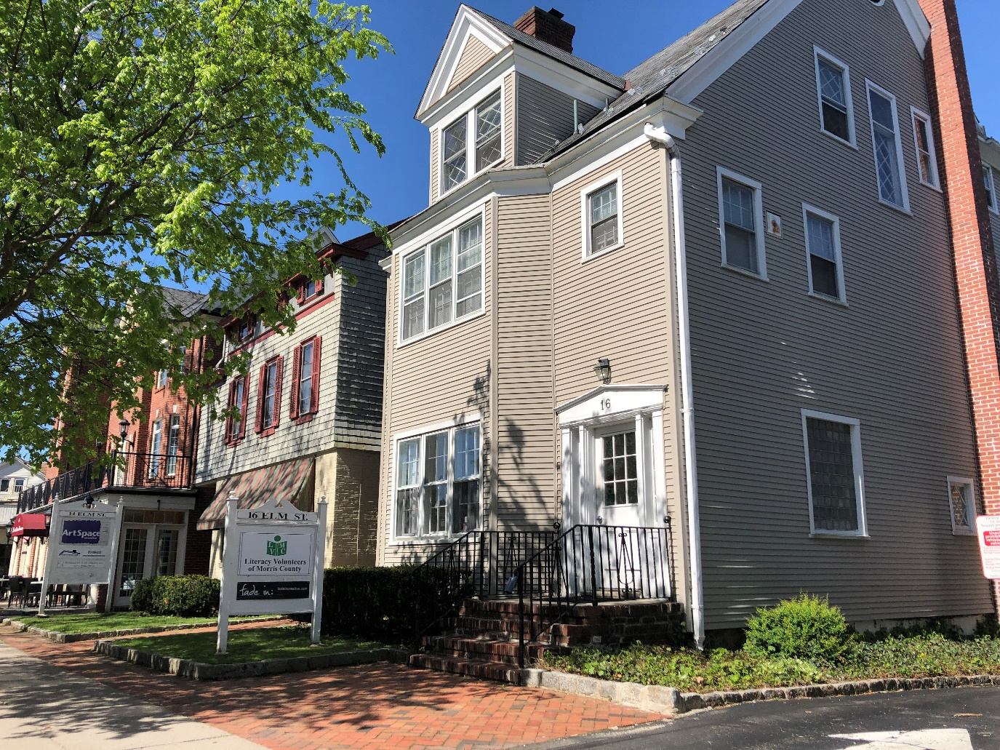
16 Elm Street, Morristown, NJ 07960 www.lvmorris.org

2018 ANNUAL REPORT

ABOUT US
Literacy Volunteers of Morris County (LVMC) offers free in-person literacy instruction to help adults function independently in society. We have provided foundational support for one-on-one and group lessons for more than 30 years. LVMC is one of the largest literacy programs in New Jersey and maintains certification by ProLiteracy, a national adult literacy standards group.

In the last five years, LVMC students have achieved over 10,000 personal goals.
-

With the dedication of volunteers and part-time staff, LVMC is able to keep expenses to less than $1 dollar per student, per day. In addition to individual and small group tutoring, we provide instruction in pronunciation, US history, preparation for the US citizenship test, American customs and manners, math, basic essay writing, resume guidance, and GED preparation.

Our Students We serve any person who needs help with foundational English communication or math skills. This includes people who were born in the United States and those who have come here speaking other languages. Our ESL students come from over 60 different countries.
Our Tutors
Volunteers are trained by our experienced staff. Our comprehensive training prepares tutors with basic teaching skills and cultural awareness. Tutors receive customized support from our staff and access to a library of materials designed for the adult learner.
Each Year
Together, tutors, students, and staff accomplish thousands of individual goals. In the last five years, students have achieved over 10,000 goals: More than 250 were able to find jobs; more than 150 became US citizens; hundreds were able to start college, vote, use a computer, handle their medical care, and become more independent, engaged, and self-sufficient members of our community.

Please continue reading for more details on our work this past year. Thank you for helping us give the gift of literacy!

Debbie Leon
Executive Director
We open more than books, we open doors
2018 PROGRAM OVERVIEW

648  Students  Served | LVMC  FACTS | 305  Active  Tutors
84% of Students met one of their goals after 12 hours of instruction | 41 unemployed Students  found  a job | 161 Students were better able to perform their current job
24 Students became U.S. citizens | 61 Conversation groups met throughout Morris County | 400 students were better able to handle their every day survival needs
280 Tutor/Student Pairs met during the year | LVMC Students came from 60+ different countries | 89  New Tutors  Trained

REFLECTIONS FROM TUTORS AND STUDENTS
“After the age of 50, I never thought I could immigrate to another country and start a life from ground zero. There are so many difficulties of attempting such an endeavor besides just finding a job and place to live. I’m so lucky to have found such a national treasure that is LVMC. No other institution is even close to it, and everyone volunteering and offering his or her help to me and my family is the reason why we are who we are as a family today. We cannot be more thankful.” Nilgun Uysal, from Turkey  “Thank you for the help and support that you have given to me, to be a part of this country. I not only learned English but solidarity and a desire to make a better world.” Marta, from Argentina  “LVMC is important to me because it helps me to communicate with people. Everyone at LVMC is friendly, I feel comfortable at LVMC, and my English is improving. I really like the teachers and staff here. They help me to adapt to my new life in the U.S.”  Jenny from China  “The ESL volunteer help means a lot to me. It was a big change in my life. After coming to classes, I started to feel more confident in my practical ways during my everyday life. I can communicate much better and understand what is happening around me.”  Norma, from Mexico  “You did not only teach me what is good here is US But you also inspired me to do good in life. You are a great teacher and a good human being. Talking to you is always like taking a deep dive into an ocean full of knowledge and wisdom. You are the best. You are more than a teacher to me. You have been a wonderful mentor and an amazing person for me. I feel grateful having such a wonderful teacher.”  Tejal, from India | “I have lived in NJ for almost 6 years, for the first 4 years of my residence I didn’t know LVMC which was sad and made me struggle in many parts of my life. I’m now so happy to attend LVMC’s English class. In the past 2 years, I’ve made big progress in my speaking skills and listening comprehension. With LVMC’s tremendous help, I felt very comfortable during my naturalization. Now I’m a U.S. citizen. I couldn’t have done such an achievement without LVMC’s help.” Wei, From China  “LVMC is important to me because I want to learn English so I can be independent. When I came to the U.S. I couldn’t speak English. Now I can write, read and I can speak very well.” Fatema, from Afghanistan  “I am very happy and thankful that I became a US citizen. It took a long time and was stressful for me, but now I’m feeling part of this beautiful country which I respect and love already. My independent life started here so I hope I can keep building my family, feeling safe and blessed.”  Soledad from Chile  “I am proud to be associated with an organization that offers free and accessible education with respect and value for every individual. I realize that many English language learners would be faced with very limited options but for the effort of agencies like LVMC. But mostly, this experience has provided me with new perspective, a boost to my confidence, and an increased awareness and appreciation of custom and culture.”  Pam Cucco, Tutor since 2017  “I am so fortunate because I get to travel the world every week with my students. As they learn to speak English, I learn of their countries, cultures, food, political issues, etc. Most importantly, I am rewarded by their excitement as they conquest the new vocabulary, grammar, idioms etc. of  their new country.”  Nancy Cunningham, Tutor since 1998  “I’ve been a tutor for a while now and it has been a wonderful experience. I love tutoring and teaching. I’ve had a lot of wonderful students and have learned a lot form them. LVMC is a wonderful organization that is trying to help people move forward and have a better life.”  Roy Morance, Tutor since 2011
ANNUAL EVENTS
Turkey Trot
Every year, LVMC partners with the Interfaith Food Pantry to host a 5K race on Thanksgiving Day. Our organizations come together because we support those who are less fortunate, which is something that many of us think about each year at Thanksgiving. Running for these causes provides an opportunity to celebrate gratitude that is healthy, fun, and has become a tradition for many Morris County residents. The event raises money for each organization and also helps raise awareness of the need for new volunteer tutors.
Thanksgiving Potluck Supper

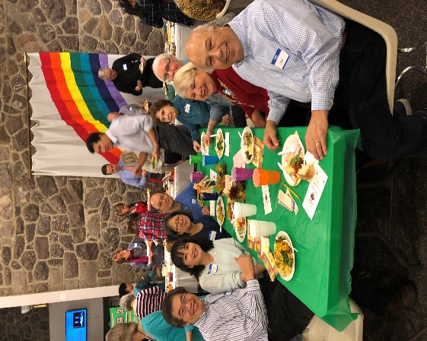
To celebrate our community, LVMC holds a dinner each November at Thanksgiving time. More than one hundred tutors, students, staff, and volunteers come together and acknowledge the accomplishments of the year. The event includes a basket raffle and award ceremony. Our 2018 Tutors of the year were Doug Drosin, Christine Hasenbein, Eileen Ceconi and Russ D’Italia. Library Director Chad Leinaweaver and the Morristown and Township Library were also recognized for their amazing support of literacy.
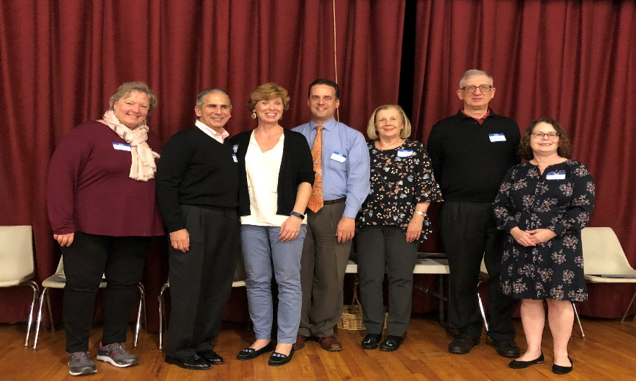
From Left: LVMC Board President Karin Kruse, Doug Drosin, Christine Hasenbein, Morristown Library Director Chad Leinaweaver, Eileen Ceconi , Russ D’Italia and Executive Director, Debbie Leon

Raise a Racquet for Literacy

In May, The LVMC Board, led by Emi Chalker, organized a fundraiser at the Mendham Health and Racquet Club that raised more than $3,000 to support LVMC. Friends and Tutors had a great time playing tennis and pickleball, and bidding on gifts at our Silent Auction. Get your tennis whites ready so you can come out and support us at our next Raise a Racquet for Literacy fundraiser.

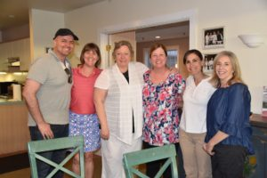
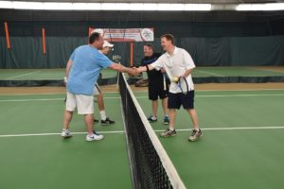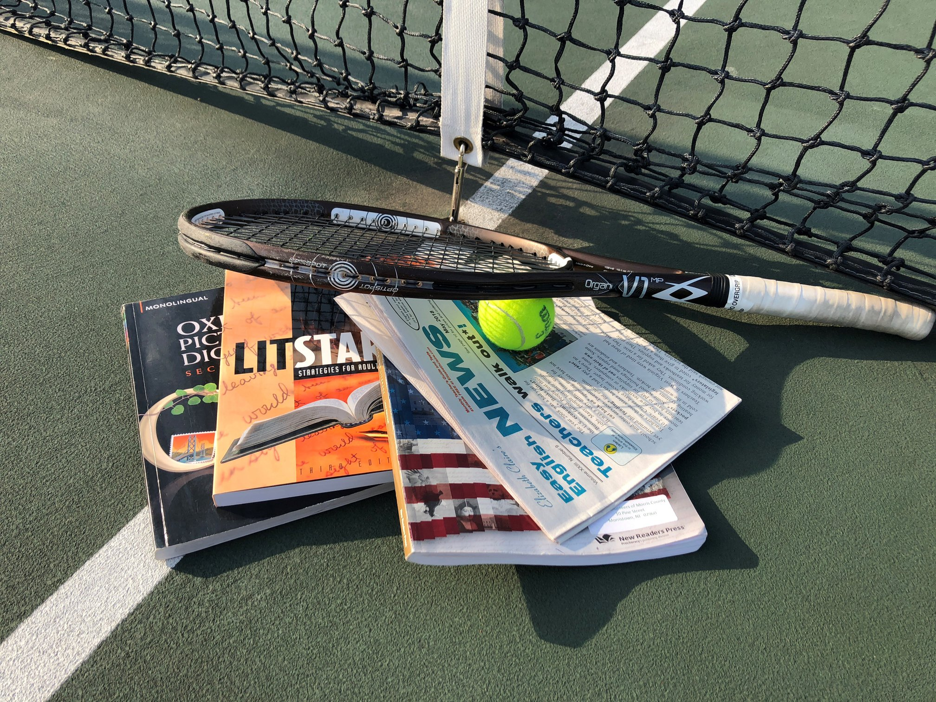

LVMC Board members German Gomez, Jennifer Thackery, Karin Kruse, Diane Miller, Danielle Shannon and Susan Ticker

Wine Tasting
LVMC Assistant Director, Bevin Tierney, tending bar
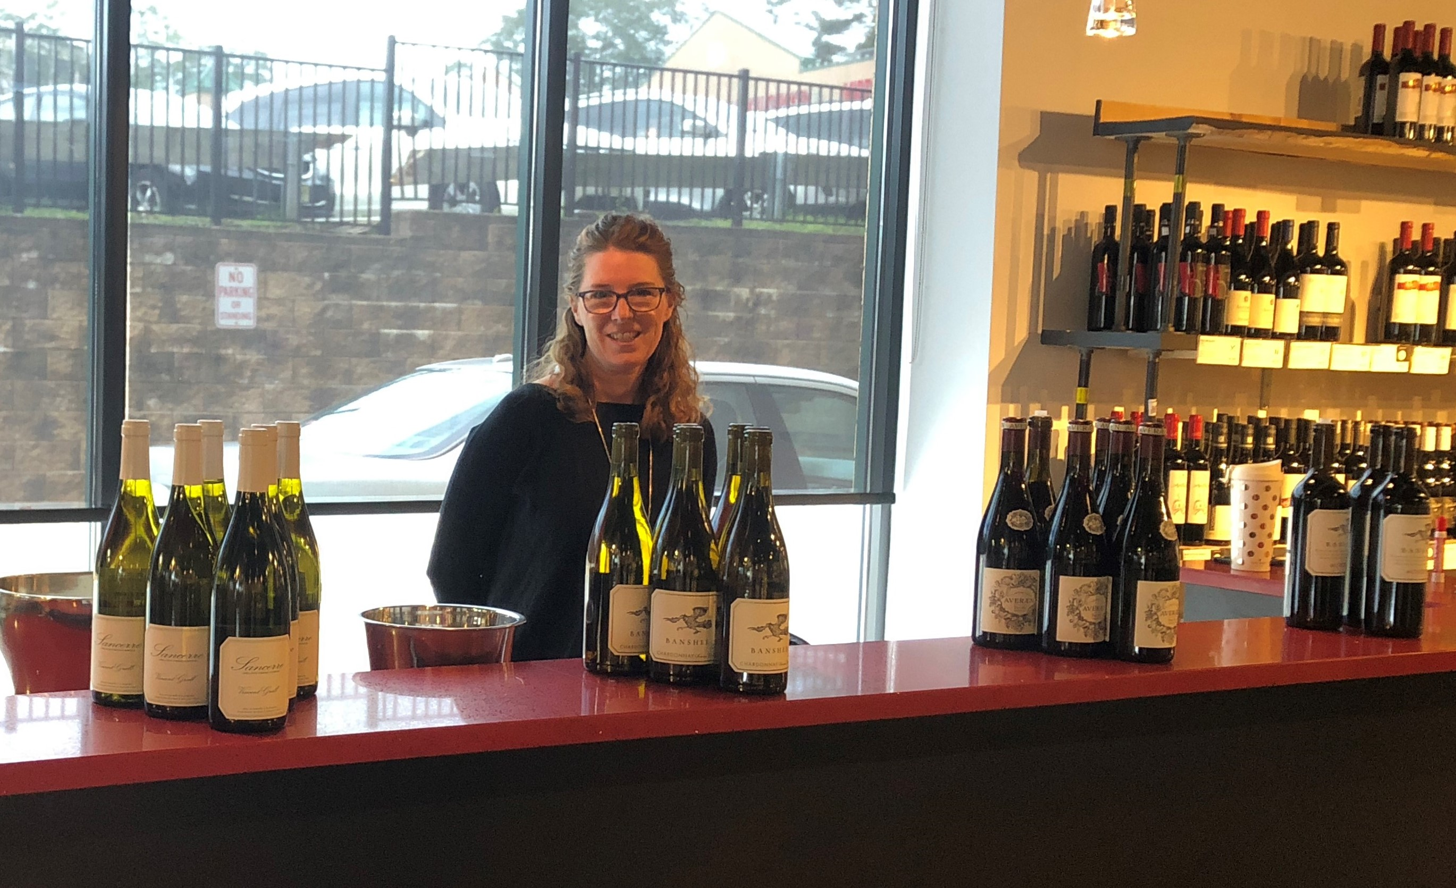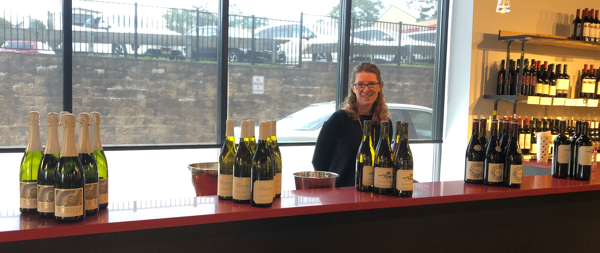
The LVMC board was busy raising money during the year, sponsoring a wine tasting event at Cambridge Wines in Morristown. In October, Tutors and friends were invited to taste a variety of wines and buy their favorites for their holiday table. Thank you to Marci Silbert for organizing this event, which raised more than $2,000 for LVMC.
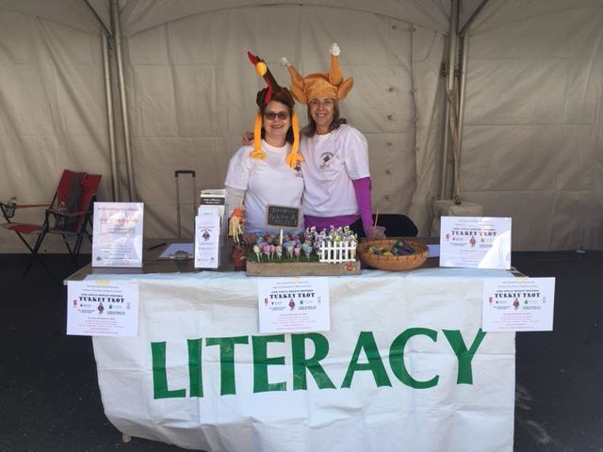
Morristown Fall Festival

Every year, LVMC participated in the Morristown Fall Festival, as a way of spreading the word of our programs to potential tutors and students, and publicize our upcoming Turkey Trot.
LVMC Executive Director Debbie Leon and board member Susan Ticker gamely wearing Turkey hats at the LVMC booth

Scenes from our Classes and Workshops

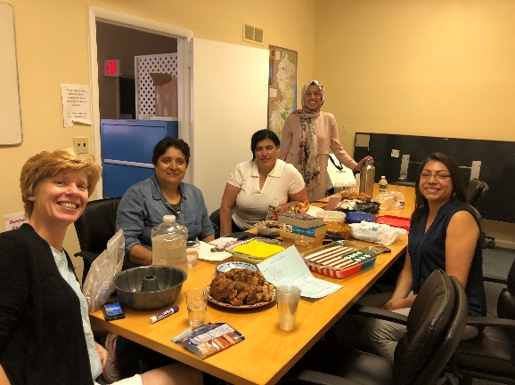
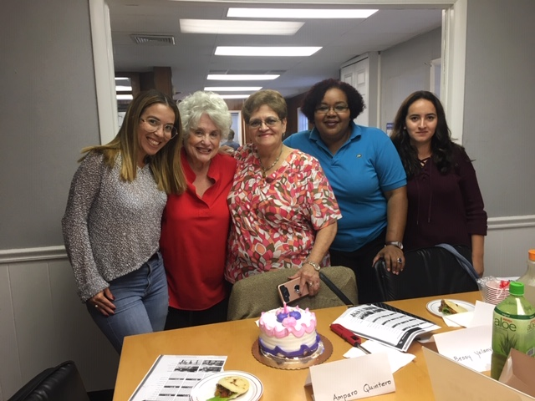
Amparo’s birthday celebration
An International Potluck with Christine’s class
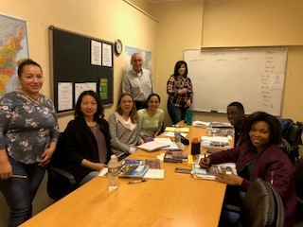
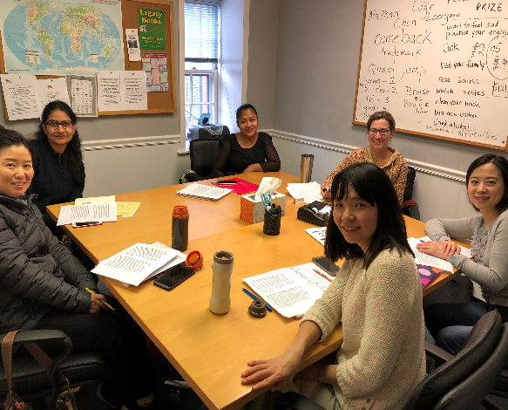
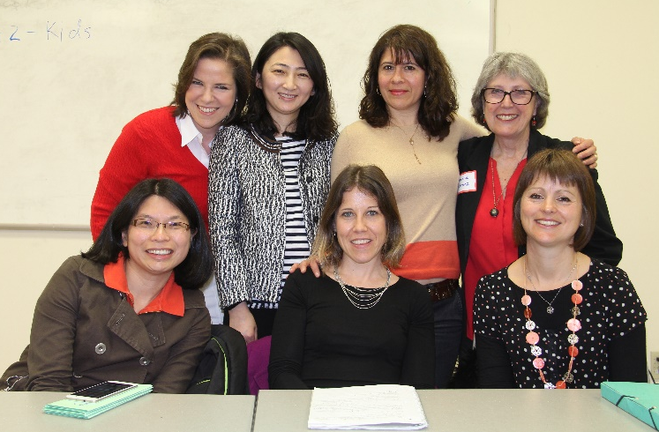
Dana’s conversation group
Bob with his beginner class

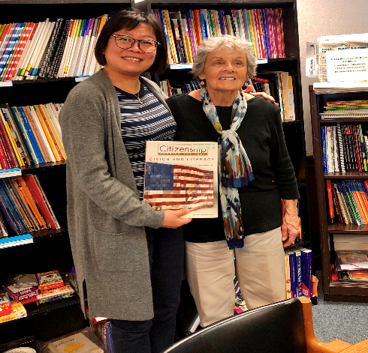
New citizen Wei celebrating with tutor Nancy
In the News Class with Pamela and Students

2018 FINANCIAL STATEMENT

Revenues
Foundations and Corporate Grants $ 70,222
Individual Contributions $ 21,374
Program Fees $ 3,873
Special Events $ 54,595
Total $ 150,064

Expenses
Program $ 147,664
Management $ 20,620
Fundraising $ 5,869
Total $ 173,973

Decrease in in Net Assets $ (23,909)

Net Assets, beginning of year $ 176,793

Net Assets, end of year $ 152,884

CORPORATE, FOUNDATION AND COMMUNITY SPONSORS

Allergan Foundation | Merck Foundation
AT&T | Rick and Diane Miller Family Foundation
Boye Foundation | New Jersey Natural Gas
Chalker Family Foundation | North Jersey Development Corporation
Chatham United Methodist Church | Novartis
Day Pitney LLP | PBF Holding Company
Edward Jones (Rich Tierney Financial Advisor) | Pfizer Foundation
F.M. Kirby Foundation | Pierson Family Foundation
Gardner Family Foundation | Provident Bank
Paula and Jerry Gottesman Foundation | Rogers Foundation
Hyde and Watson Foundation | Rotary Club of Madison
Investor’s Foundation | Lillian Schneck Foundation
Judith Sacks Bliss Philanthropic Fund of the Jewish Communal Fund | Shapiro Family Foundation
Kiwanis Club of Randolph | Sweetie Pig Foundation
LVMC Board of Directors | United Way of Northern New Jersey
Steve and Mancy Magee Charitable Trust | Vernon Library Supplies
Marino Family Foundation | Wells Fargo
 | Women’s Club of Parsippany

THANK YOU TO OUR GENEROUS DONORS!
Every attempt has been made to recognize the generous contributions of our donors.
We apologize for any errors. If you feel that your name should appear on this list, or if it appears
incorrectly, please let us know!
Individual Donors
 | Alicia Adarve | John Cohn | Jay Grossman | Patricia Libak | Joe and Mildred Paden
 | Veena Agarwal | Irilys Conde | Don Guerin | David Lin | Guilia Paone
 | Luz Maria Aguilera | Judy Conroy | Purnima Gunasekar | Rachel Lin | Cynthia Parello
 | Richard and Eleanor Aiken | Cathy Corbo | Florence Halbert | Sammy Lin | Christine Parlapiano
 | Jodi Lee Alper | Natasha Cordero | Mingxia Hall | Ken Lipkin | Chloe Park
 | Joan Anderson | Marilene Cosentino | Tish Hamilton | Yabing Liu | Eun Young Park
 | Robert and Gloria Anderson | Isabelle Coudurier | James Hanrahan | Alice Long | Jina Park
 | Angelina Angeles | Barbara Couillard | Patty Haralampoudis | Julia Lopez | Madeline Pasteelnick
 | Ed Antel | Mike Daly | Roger Harkavy | Sergio Lopez | Ellen and Alan Pearl
 | Olena Arnautova | Ligita Damberga | James Harrington | Jeanine Losito
 | Aura Avila | Maria DaSilva | Dolores Hayowyk | Ivonne Maritza Lozano | Jeanne Perry
 | Tin Tin Aye | Sunanda Datar | Valerie Heerwagen | Susan Lu | Leslie Pessemier
 | Kyeongmin Bae | Maria DeCosta | Katherine Henckler | Pat Luthy | Eric Peterson
 | Li Hua Bai-Viggiani | Jim Dellureficio | Al Himmelstein | Lyudmyla Mahzdyar | Maria Petit
 | Charles Ballinger | Carolyn DeLorenzo | Marie Hogerty | Patricia Manfre | Nancy Pierson
 | Dan Balogh | Timothy Devaney | Linda Holmquist | Pat Mansfield | Dana Pogorzelski
 | Kathleen Banks | Gail Dewees | Natalia Hosteiva | Christine Mao | Miguel and Anita Porto
 | Michael Baruffi | Doris Dhar | Nancy Hults-Rubin | Cheryl Marchiarullo | Janet Proscia
 | Robin Batten | Fabio Diaz Lopez | Yelvart Istanbul | Susan Margolin | Marili Quintos
 | Susan Beekman | Inge Digiacomo | Jany Izaguirre | Paula Marino | Christine Rachalis
 | Janie and Philip Bell | Sharon Donatoni | Kum Ja | Fred Marks | Katherine Ramos
 | Vincent Benoit | Mary Beth Donoghue | Sandy Jacobson | Rosalie & Bob Marmara | Kenneth Ratigan
 | Beth Berger | Lawrence Driscoll | Jim and Lynne Johnson | Carine Martial | Jane Rauen
 | Marlene Besdansky | Doug Drosin | HyunJun Ju | Shaune Marx | Frank Razzano
 | Tulsi Bhalodia | Patricia Dufort | Margaret & Michael Judge | John & Michelle Mascaro | Carmen Reiban
 | Stephen Bier | Jill Dupuy | Nejat Kancoban | Sandra Mathews | Patrick and Holly Reilly
 | Gloria Biolsi | Mimi Eddleman | Jaejin Kang | Linda McCabe | Roberto Reisinger
 | Lourdes Blanco | Kristin Elliott | Ari Kaplan | Nial McCabe | Ronald Ribnik
 | Ken Blankfein | Bill Ennis | Joanne Kares | Maureen McCarthy | David Rivchin
 | Angela Bioshuk | Pamela Estevez | Louise and Dan Karger | Deborah McComber | Mabel Rodriguez de Romero
 | Priscilla Boles | Pam Etzold | Mariana Karpatova | Valerie McCoy | Carol Rogers
 | Frederick Bossard | Bob Falcone | Barbara Keelty | Virginia McDonnell | Laura Rogers
 | Vincent Bove | Carol Falk | Ann Kelsey | Douglas McMahon | Nancy Rosenfield
 | Jeffrey Braemer | Weiya Fang | Gale Kenny | Mary Meeks | Norman Rosenthal
 | Ailing Chao | Charlotte Farlow | Soon Kil | Diane Meza | Joanne Roukens
 | Caroline Charlet | Ana Fernandez | David Kimm | Donna Michaelizysen | Faith Rubenstein
 | Helen Chen | Ricardo Fernandez | Colleen Kirkhart | Mary Ann Michalski | Amy Rubinetti
 | Geoffrey & Crary Brooks | Shelia Figman Eule | Kathleen & Robert Kirpitch | Alex Miller | John Rudder
 | Leslie Brown | Paula Firestone | Anne Kneller | Diane Miller | Janice Rutherford
 | Maria Buckel | Judy Flammino | Annette Koch | Jack Miller | Dimitrios Salamandrakis
 | Donna Burkey | Mary Fleming | Kathleen Koopman | Muriel Millman | Fernando Salas
 | Robert and Mary Bush | Maria Florez | Eleanor Kopido | Hector Mislavsky | Norma Salas
 | Richard Bye | Rep. Rodney Frelinghuysen | Alice Koster | Patricia Mitchell | Maria Saldivar
 | Raymond Carriere | Jennifer and David Friedland | Marianne Kozlowski | Ariadne Monfalcone | Lorna Samaneigo
 | Ray Casarico | Diane Fristachi | Nancy Krumholtz | Sara Montijo | Lizeth Santiago
 | Eileen Ceconi | Joan Garbarino | Karin Kruse | Patricia Mooney | Onesimo Santiago Martinez
 | Jeanne Chang | Kathleen Gardner | Steve Kwasney | **Roy Morance | Nancy Sautello
 | Sandy Chang | Bonnie Gardner | Polly and Ron Lacey | Valerie Morgan | Maria Fabiana Savaresi  De Costa
 | Matthew Chanin | Joe Gehrum | John Launchi | Michael Moschella | Sylvia Schlumpf
 | Caroline Charlet | Mija Gellerman | Phuong Le | Kodsia Majem | Ann Schneider
 | Fei Wen Chen | Melissa Gencarelli  & Nick Rimassa | Mary Betsabe  Leal Molina | Ana and Jorge Narvaez | Michael Schwam
 | Hailei Chen | Margaret Giardina | Gregory & Nancy Leck | Ray Mazzaro | Anthony Sciglitano
 | Helen Chen | Andrea Goldstein | Brenda Lee | Anna Ni | Alex Scott
 | Patricia Chen | German Gomez | Chun Mei Lee | Barbara and Alan Niedz | Tanya Seaward
 | Shirley Chen | Lizeth Gomez-Santiago | Kum Ja Lee | Maria Norton | Danielle Shannon
 | Sandy Cherniack | Geordie Grant | Carol Leiwant | Karen Ocker | Azita Sharif
 | Eileen Chin | Laura Grant | Debbie Leon | Michelle & Peter Olinto | Katherine Shih
 | Faith Chinskey | Kim Grantham | Randi Lesser | Ewelina Opilowska | Satinder Sidhu
 | Seon Young Choi | Anush Grigoryan | Susan Levant | Melissa Yamileth Ordonez | Susan Siegrist
 | Lawrence Clamam | Pintipa Grongsaard | Edee Levey | Barbara Owens | Marci Silbert
 | Allison Clark | Laurie & Phil Gross | Makbule Lewis | Nancy Oyer | Brian Simon
 | Grace Clemente | Phillip Grossman | Alexander Leyzerov | Viviana Pacheco | Katie and Paul Skilton
Names in Bold Denote a donation of more than $200
** Denotes a monthly donation

 | Individual Donors con’t
 | Alan and Diane Sklar | Diane Tolkowsky | Isobel Wayrick
 | Richard Smith | Carolyn Tordella | Sherry Weiner
 | Barbara Snyder | Emin Sanin Tuncbilek | Sara and Bob Weissman
 | Gordon Snyder | Gretel Uptegrove | Kent Werry
 | Beatriz Solorzano | Robert Urban | Ryszard Wesolowicz
 | Charles Steinberg | Alexandra Urday | Charlotte Wilson
 | Leslie Stevens | Nilgun and Nadir Uysal | Royce Wintz
 | Brittany Steward | Claudia Valdivia | Meg and Jim Wiviott
 | Marie Stiven | Romina Valente | Laura Wood
 | Barbara Stromberg | Jane Van Wiemokly | Mary Jo Woodford
 | John Svolos | Juan Jose Vargas | Jenny and Lang Wu
 | Marta Swoeszkowski | Christopher and Yvonne Ventresca | Kathy Wu
 | Joanne Tabeek | Marianna and Remo Vigano | Yuling Wu
 | Jennifer Thackery | Janet Vignola | Lily Xu
 | Susanne Thevenet | Linda Vivilecchia | Xiao Luo Yuan
 | Susan Ticker | Mary Anne Walldorf | Jungmi Yun
 | Bevin and Rich Tierney | Sylvia Walsh | Yu Chen Yun
 | Julie Tierney Gerke | Scarlett Wang | Brigid and Stephen Zajec
 | Sucharita Tilak | Shiow Reen Wang | Ying Zhang
 | Richard Tisdale | George and Josephine Washburn | Carol Zimmerman Joyce
 | Veronica Tobia | Branch and Bryna Watkins | Lynn Zwigard
Your Donation
LVMC receives no government funding, and relies completely on support from individual and corporate donors. Contributions help us provide the infrastructure to make each lesson possible. Overhead costs are kept low to ensure that funding can support our tutors and students.

100% of our funding comes from community support and
.90 cents of every dollar directly supports our students and tutors.

How do we use the money you donate?

$40 provides a one year subscription for a newspaper designed for the ESL student
$100 helps a student prepare for the General Equivalency Diploma (GED)
$150 sponsors an English as a Second Language student for one year
$250 sponsors a Basic Literacy student for one year
$200 pays for preparation materials for the US Citizenship test
$1,000 trains 25 new volunteer tutors
$3,000 pays our rent for one month

OUR MISSION

Literacy Volunteers of Morris County believes that the ability to read, write, comprehend and speak English is essential for personal freedom and the sustainability of a democratic society. Our mission is to provide free instruction to Morris County adults in literacy, English fluency and American culture.

BOARD AND STAFF
Karin Kruse, President Emi Chalker Danielle Shannon
Nick Rimassa, Vice President German Gomez Marci Talbert
Allison Clark, Treasurer John Launchi Jennifer Thackery
Susan Ticker, Secretary Alex Scott

Debbie Leon, Executive Director
Bevin Tierney, Assistant Director
Kathy Talbert, ESL Program Coordinator
Anita Porto, ESL Program Assistant
Elizabeth Gavilanes, ESL Program Assistant
Rosalie Marmara, ESL Program Assistant
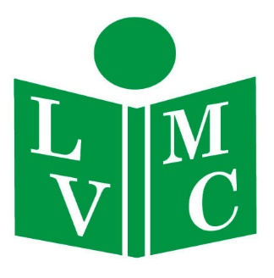
Literacy Volunteers of Morris County
16 Elm Street, Morristown, New Jersey, 07960
www.lvmorris.org

