Literacy Volunteers of Morris County
2019 Highlights

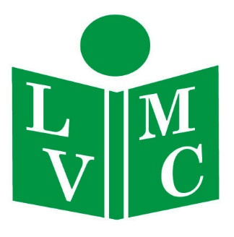
For more than thirty years, the vision of Literacy Volunteers of Morris County has been to ensure no one in Morris County finds their opportunities in life limited because of their inability to read, write or speak English fluently. To that end, in 2019, LVMC provided free, life changing tutoring and mentoring to almost 700 students from more than 60 countries.
Our students learned about their community, how to speak to their customers and employers, and practiced speaking with medical personnel. They found jobs, learned to be more empowered consumers, became U.S. citizens, and found supportive friends at LVMC as they made their new lives in this country.

We could not have done it without the help and support of our amazing tutors, donors and champions. Thank you for giving the Gift of Literacy, and for making our small part of the world a better place.

Literacy Volunteers of Morris County 16 Elm Street Morristown NJ 07960
www.lvmorris.org
691  Students  Served | We opened a new office at  16 Elm Street | 326  Active  Tutors
95% of Students met one of their goals after 12 hours of instruction | 35 unemployed Students  found  a job | Students achieved 152 of their employment goals
17 Students became U.S. citizens | 84 Conversation groups met throughout Morris County | 359 students were better able to handle their every day survival needs
“I’m so lucky to get your help and care at the beginning of my new life in the US. I feel comfortable speaking English with strangers.” Fang Fang, from China
Fammu. Frp,
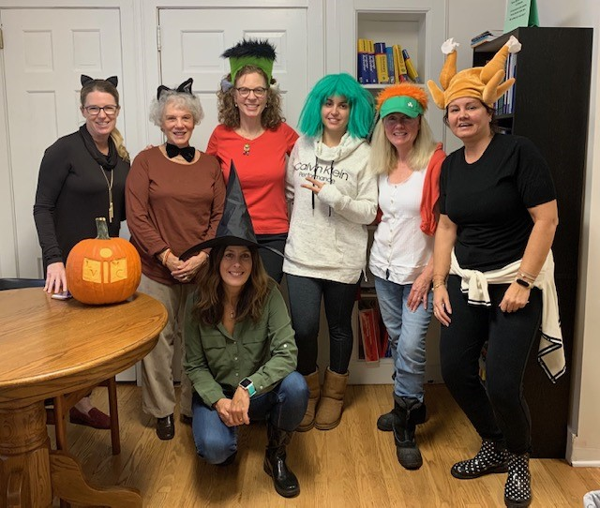
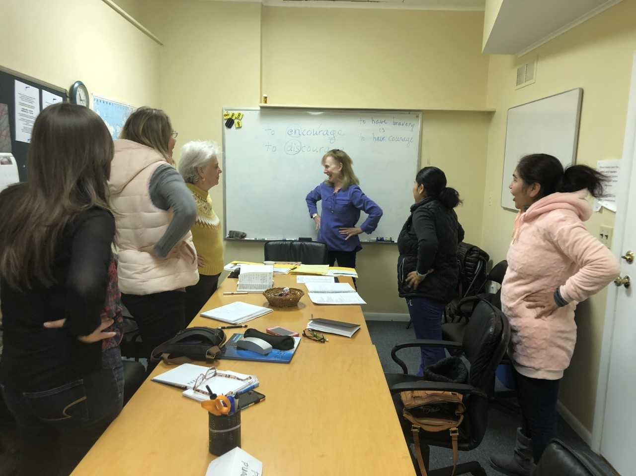
“Without LVMC, my dream wouldn’t be possible. I reached the biggest dream: I have my citizenship.” Maria, from Mexico
“My tutor helped me write my resume and I’ve gotten a job.” Natalia, from Kazakistan
“I had to take my daughter to the ER because of an asthma attack. I was able to communicate with the medical professionals.” Jenny, from Colombia
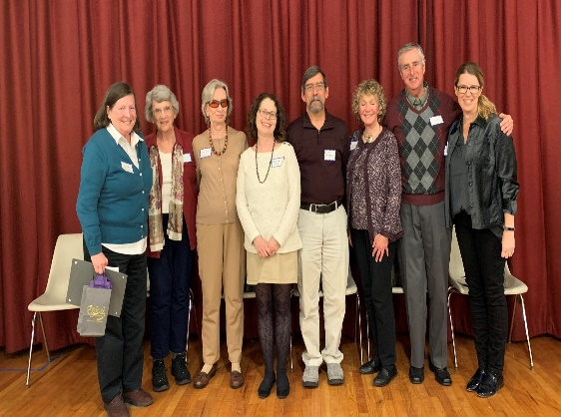
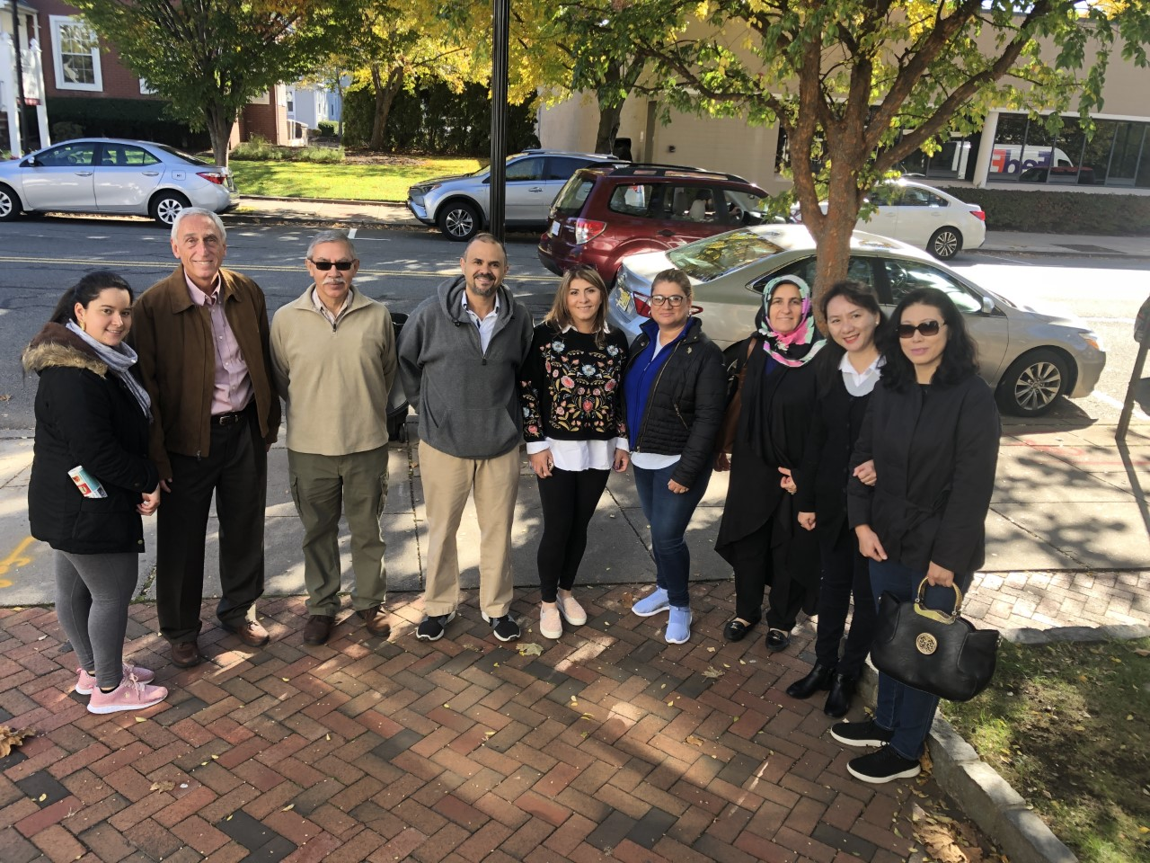
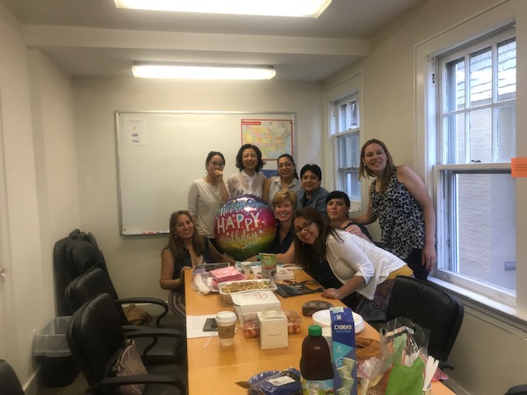
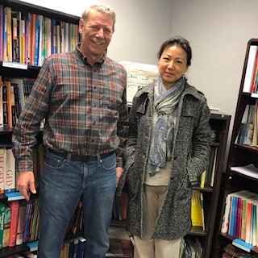
“Thank you so much for embracing me as part of your LVMC family and helping me become fluent and self-confident in English.” Milena, from Brazil
CORPORATE, FOUNDATION AND COMMUNITY SPONSORS
In Memory of Donations and Bequests
We thank the friends, families and estates of the much loved and much missed tutors we lost in 2019:
Ann Schneider, Genevieve Hayes, Alice Koster and Alice Neeb
To support LVMC, please send your tax deductible contribution to: LVMC, 16 Elm Street, Morristown NJ 07960 or online at www.lvmorris.org.
Please remember us in your will or trusts

Atlantic Sports Health | Lexus of Route 10
John Bickford Foundation | New Jersey Natural Gas
Boye Foundation | New Jersey Orthopaedic Institute
Burns & McDonnell | Craig Newmark Philanthropies
Chalker Family Foundation | North Jersey Development Group
Chatham United Methodist Church | Novartis
Chrysalis Pharma Partners | PBF Energy
Community Foundation of New Jersey | Pfizer Foundation
Dermody Properties Foundation | Pharm Counsulting
Dixon Brothers | Provident Bank
Edward Jones (Rich Tierney Personal Advisor) | Rotary Club of Madison
Paula and Jerry Gottesman Foundation | Rogers Family Foundation
Greater Morristown YMCA | Fred C. Rummel Foundation
Horizon Foundation | Sweetie Pig Foundation
Investors Foundation | TE Industries
Kearney Federal Savings | Women’s Club of Parsippany
F.M. Kirby Foundation | Wells Fargo
THANK YOU FOR GIVING THE GIFT OF LITERACY
Every attempt has been made to recognize the generous contributions of our donors.
We apologize for any errors. If you feel that your name should appear on this list, or if it appears
incorrectly, please let us know!
Alicia Adarve | Pamela Estevez | Elena Kushnerov | Jeanne Perry | Christopher & Yvonne Ventresca
Richard & Eleanor Aiken | Pam Etzold | Steve & Joyce Kwasney | Nancy Pierson | Marianna & Remo Vigano
Sara Amouzadeh | Beatrice Fagan | Polly & Ron Lacey | Dana Pogorzelski | Janet Vignola
Joan Anderson | Robert Falcone | John Launchi | Miguel & Anita Porto | Aida Visakay
Nicole Anderson | Carolyn Falk | Gregory & Nancy Leck | **Sharon Prime | Linda Vivilecchia
Angelina Angeles | Charlotte Farlow | Chuanyin Lee | Lorraine Quevillon | Mary & Jim Walker
Ed Antel | Sheila Figman Eule | Kum Ja Lee | Christine Rachalis | Mary Anne Walldorf
Karina Araujo | Paula Firestone | Francois Levesque | Ivo Rancic | Florence Walsh
Aviva Arnuk | Judy Flammino | Patricia Libak | Frank Razzano | George & Josephine Washburn
Jack and Carol Ayres | Maria Florez | Carol & Charles Leiwant | Carmen Reiban | Bryna Watkins
Charles Ballinger | Jeff Flyer | Helen Harris Lindeman | Brooke Reilly | Isobel Wayrick
Jim & Linda Baratte | Sister Margaret Foster | Ken Lipkin | Dana Reilly | Sally Jo Weber
Robin Batten | Jennifer & David Friedland | Armando Londono | Roberto Reisinger | Bob & Sara Weissman
Anne Beacken | Marilin Milena Galvis Vasquez | Alice Long | David Reitsma | Barbara & Kent Werry
Francene Beel | Bonnie & Harrison Gardner | Sergio Lopez | Ronald Ribnik | Joan & Keith Willoughby
Janie and Philip Bell | Kathleen Gardner | Lucy Loux | Nick Rimassa | Charlotte Wilson
Andrea Beltram | Joe Gehrum | Ivonne Maritza Lozano | David Rivchin | Catherine Wilson
Beth Berger | Mija Gellerman | Margaret Lozauskas | Ana Rodriguez | Doug & Royce Wintz
Marlene Besdansky | Julie Gerke | Pat Luthy | Leo & Carole Rogers | Meg & Jim Wiviott
Tulsi Bhalodia | German Gomez | Nancy & Steve Magee | Norman Rosenthal | Yuling Wu
Kenneth Blankfein | Lizeth Gomez-Santiago | Patricia Manfre | Amy Rubinetti | Kathy Wu
Karen and Paul Blodgett | **Steve Goscinski | Susan Margolin | John Rudder | Lang and Jenny We
Priscilla Boles | Walmer Granda | Paula Marino | Janice Rutherford | Lei You
Lily & Vincent Bove | Geordie Grant | Rosalie & Robert Marmara | Judith Sacks Bliss | Mary Yu
Jeffrey Braemer | Kim and William Grantham | Masella Family Fund | Fernando Salas | Brigit & Stephen Zajec
Gilzeth Brito | Cliff Greenwood | Sandra Matthews | Lorna Samaniego | Jenny Zhang
Yongjie Bu | Kate Griggs | Linda Matul | Teresa Sanchez | Carol Zimmerman
Wilfrid Bulin | Laurie and Phil Gross | Lyanne McAuliffe | Alan Schaffer | Lynn Zwigard
Robert & Mary Bush | Meizhu Guo | Linda McCabe | Jan Schwartzberg
Patricia Cano | Toni Guss | Valerie McCoy | Alex Scott
Marilyn Carnicelli | Florence Halbert | Virginia McDonnell | Stuart Scott
Frederick Bossard | Mingxia Hall | Doug McMahon | Hana Sefcik | 2019  Individual Donors
Raymond Carriere | Roger Harkavy | Patricia Mead Walsh | Danielle & Edward Shannon
Ray & Beverely Casarico | Lorelei Harris | Mary Meeks | Shapiro Family Foundation
Joseph Castignetti | Margaret Haughey | Matthew Mergen | Satinder Sidhu
Eileen Ceconi | Dolores Hayowyk | Donna Miceli | Susan Siegrist &  Denise Beckman
Ana Chala | Valerie Heerwagen | Amy Miller | Aika Singh
Chalker Family Foundation | Concetta Helble | Alex Miller | Scott Siripalaka
Caroline Charlet | Al Himmelsteib | Diane Miller | Gordon Snyder
Jenny Chen | Marie Hogarty | Muriel Millman | Teresa Stavisky
Patricia Chen | Natalia Hosteiva | Hecktor Mislavsky | Charles Steinberg
Sandra Cherniack | Michelle Hsieh | Elizabeth Montecinos | Paul Steiner
Allison Clark | Yelvart Istanbul | Patricia Mooney | Marie Stiven
Grace Clemente | Sandra Jacobson | ** Roy Morance | Norman Stone
Jocelyn Cornine | Vincent Jacobson | Valerie Morgan | Barbara & John Stromberg | Names in bold denote donations of $200 or more
Isobel Coudurier | Margaret & Michael Judge | Marguerite Moscatello | Jane Su
Barbara Couillard | Duygu Kaplan | Sunny Mou | Wendy and Greg Supron
Ligita Damberga | Joanne Kares | Howard Myers | Joanne Tabeek
Maria DaSilva | Mariana Karpatova | Kodsia Najem | Shelly Templeman | **Denotes a monthly donation
Sunanda Datar | Ronnie Kaufman | Rhongdan Nakajima | Tes Tesfamariam
Jim Dellureficio | Laura Kaufmann | Joseph Nappa | Jennifer Thackery
Julie Deluca | Barbara Keelty | AJ Nappa | Susanne Thevenet
Tim and Robin Devaney | Ann Kelsey | Irena Nazarova | Robert & Elizabeth Thomas
Gail Dewees | Soon Kil | Barbara and Alan Neitz | David Ticker
Dimitrios Diamantaras | Kathleen & Robert Kirpitch | Maria Norton | Susan Ticker
Inge DiGiacomo | Anne Kneller | Patricia Novy | Bevin and Rich Tierney
Monica Dodge | Annette Koch | Dennis O’Malley | Sucharita Tilak
CarolAnne Dolan | Kathleen Koopman | Viviana Pacheco | Veronica Tobia
Lawrence Driscoll | Laryssa Kot | Jane Palumbo | Kathleen Tully
Doug Drosin | Lyubov Kovalena | Hua Hua Parker | Carol Turchi
Patricia Dufort | Marianne Kozlowski | Madeline Pasteelnick | Consalvo Turchi
Jill Dupuy | Nancy Krumholtz | George Patterson | Shelby Umland
Miriam Eddleman | Karin Kruse | Ellen Pearl | Rober Urban
William Ennis | Doreen Kurzum | Silvia Pemberthy | Nadir and Nilgun Uysal
 |  | Gwendolyn Perrin | Art Van Tol

